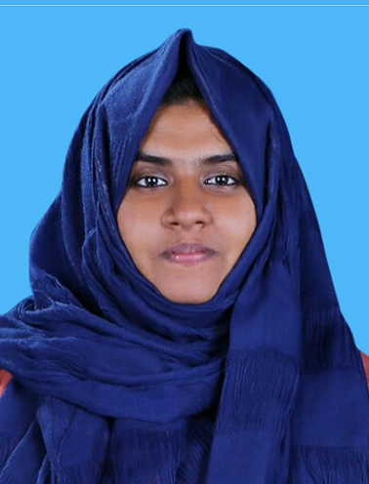
RESUME

THANZEELA ABDUL SALAM
Student Nursing Trainee

Eramangalath ( House )
Eriyad( PO ),Kodungallor
Thrissur– 680666
Kerala, India

Mob : +91 9539775663
e-mail : asalamkdr@gmail.com
---------------------------------------------------------------------------------------
CAREER OBJECTIVE
- Patient focused and empathic nurse seeking positions with growing medical practice. Bringing experience, care and extensive knowledge to improve the lives of patients.

EDUCATION
GOVT.K.V.H.S.S,ERIYAD
SSLC – ( 89%) 2013
Board of Public Examination, Kerala
M.E.S. higher secondary school
SCIENCE( 70%) 2015
Board of Higher Secondary Examination, Kerala
Santhi College of Nursing Venappara
Bsc Nursing ( 62% in Four years ) 2019
KUHS

EXPERIENCE
- Experience as a Student Nursing Trainee in Iqra Hospital, at Calicut

- Experience as a Student Nursing Trainee in Baby Memorial Hospital, at Calicut

- Experience as a Student Nursing Trainee in Kuthiravattam Mental Health Centre, at Calicut
- Experience as a Student Nursing Trainee in Iqra psychiatric Centre

PERSONAL DETAILS
Father's Name : Abdul Salam
Date of birth :30/06/1997
Religion : Muslim
Marital Status : Single
Nationality : Indian
Language known : English, Hindi & Malayalam

PERSONAL SKILLS
- Ability to deal with people diplomatically.
- Ability to manage crowd.
- Willingness to learn.
- Good Communication skills.
- Smart working capability.
- Helping mentality.
- Leadership

DECLARATION
I hereby declare that the information furnished above is true to the best of my knowledge. I do hereby declare that above particulars of information and facts stated are true , correct and complete to the best of my knowledge and belief.

Place : Thrissur
THANZEELA ABDULSALAM
Date : 15/11/2019

