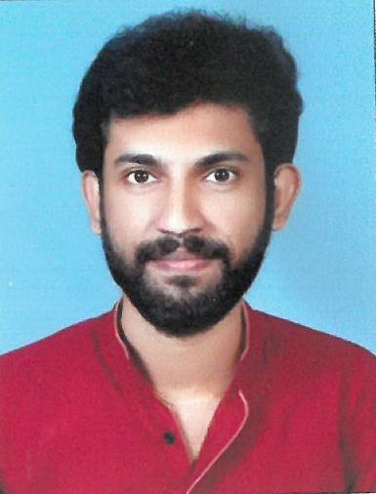

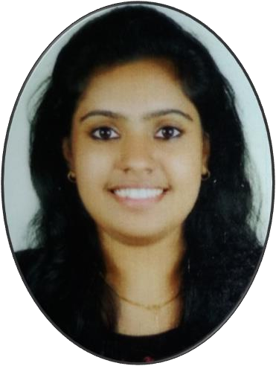CORE QUALIFICATIONS

SHEBIN THOMAS
8113032981
thomasga6@gmail.com
Gopurathinkal (H), Alangad P.O,
Thiruvalloor via, Ernakulam - 683511

- Quality audits
- Medical records management
- Independent researches and statistical analysis
- Coordinated mock drills at hospital
- Practical exposure to various clinical and administrative departments in hospital

PERSONAL SKILLS
- Excellent communication skills both oral and written
- Good interpersonal skills
- Multitasking ability
- Flexible
- Ability to work under pressure
- Team leader
- Quick learner
- Reasoning and logical skills
- Excellent computer skills especially MS Office

OBJECTIVE
To become a successful professional in the field of Hospital Administration and to work in an innovative and competitive world.

EDUCATION

MASTERS IN HOSPITAL ADMINISTRATION | 2017-2019
Little Flower Institute Of Medical Sciences And Research, Angamaly, Ernakulam (KUHS)
  - Scored 73.1% in the first year examination.

BACHELOR OF TECHNOLOGY (ECE) | 2012- 2016
Jai Bharath College of Engineering, Perumbavoor (MG University)
  - Scored 75% mark

HIGHER SECONDARY EDUCATION | 2010 - 2012
Govt. Higher Secondary School, Kongorpilly(DHSE)
Specialization in biology science
  - Scored 81% mark

HIGH SCHOOL EDUCATION | 2009 - 2010
KEM High School, Kottapuram (Board of public examination,
Govt. of Kerala)

  - Scored 83.3% mark

PROJECTS

MAGJ HOSPITAL, MOOKKANNOOR | May 2018

Researched and Prepared a Project report on the topic “Patient’s satisfaction
And hospital brand image among in patient’s orthopedics’ department in
MAGJ Hospital, Mookkannoor.”

LANGUAGES

English Malayalam Tamil Hindi

HOBBIES
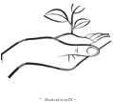
Gardening

Music

Taking Tuition

Movies

PERSONAL INFORMATION

Birthday : 17/01/1995
Gender : Male
Nationality : Indian
Marital Status : Single
Father’s
Occupation : Electrician
Mother’s
Occupation : Home

Maker
SAMARITAN HOSPITAL, PAZHANGANAD
| June 2019
Researched and Prepared a Project report on the topic “a study on Hospital information system (HIS) and its impact on quality of service in Samaritan
Hospital, Pazhanaganad.”

ACADEMIC COMPETENCIES
- Preventive and community medicine
- Basic Medical Science
- Healthcare Marketing and Strategic management
- Management of healthcare organization.
- Financial Management
- Management Accounting
- Cost Accountancy
- Legal aspects of healthcare and medical ethics
- Research Methodology and bio statistics

AWARDS & ACHIEVEMENTS

- Coordinated college fest 2019.
- Elected as Executive member of College Union 2018-2019.
- Participated in the CNE workshop on “Quality in Healthcare Practices”
- Coordinated MHA conference “HOSCON 2018”
- Participated at the National Conference “Hospica En Masse 2k17”
- Elected as School Leader 2009-2010
- Awarded 3rd prize in Medi management quiz in LIMSAR feast 2017- 2018.
- Worked as a Catechism teacher in Ernakulam- Angamaly Archdiocese from 2016

COMPUTER SKILLS
- Microsoft Office Word,Excel,Power Point
- Language: C, Kiel,8085,8086, MAT Lab, Embedded
- General and Graphic Application: HTML
- Operating System : Windows XP, Windows 7

