JENI JAYARAJ P
Paramjyothi House, Codacal Post,Malappuram 676108,Kerala
9159947299▪ jenithabeetha@gmail.com
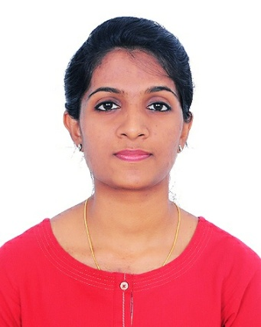
Personal Details
Date of Birth: 11.10.1995
Gender: Female
Nationality: Indian
Father’s Name: Jayarajan P
Marital status: single
Religion: Christian
Languages Known: English, Malayalam, Hindi and Tamil
Objectives
To be part of a community where I can devote myself fully & joyfully give out the best service of mine and also to improve my skills & experience in the field of optometry to become its strong assets

Academic Qualification
QUALIFICATION | DURATION | INSTITUTE | UNIVERSITY
Bachelor Of Science In Optometry | 2013-2017 | Christian Medical College, Vellore, Tamil Nadu | The Tamil Nadu Dr. M.G.R. Medical University, Chennai
eLearning training course on  Grading Diabetic Retinopathy | 1-10-2019 | - | The university of Melbourne

Conferences Attended
TOPIC | DATE | INSTITUTE
Cornea And Ocular Surface Highlights | 18th January 2014 | Christian Medical College, Vellore, Tamil Nadu
State Annual Conference And Scientific Session | 7th October 2018 | Indian Optometrists Association, Kerala
Workshop On Manufacturing And Dispensing Of Essilor Lenses | 18th February 2019 to 23rd February 2019 | Essilor India Private Limited, Yeshwanthpur, Bangalore
Diabetic Retinopathy workshop | 31st August | Indian Optometrist Association Kerala and Optometry council of India
Speciality Contact Lens Practice | 1st September | Indian Optometrist Association Kerala and Optometry Council of India

Projects
TOPIC | METHORD | DATE | INSTITUTE
Predicted and post-operative refraction usingSRK2 and SRKT in post- MSICS,outreach services patients | Retrospective audit (Chart Analysis) | August 2015-October 2015 | Christian Medical College, Vellore, Tamil Nadu

Professional Experience
- 1st December 2016 To 30th November 2017
Christian Medical College
Department Of Ophthalmology
Schell Eye Hospital, CMC, Vellore
Tamil Nadu, India
Position: Optometry Internship
- From 1st January 2018 Till Present
C.S.I Mission Hospital Codacal
Tirur, Malappuram, Kerala
Position: Optometrist

Area of Expertise
A thorough and detailed ocular examination including history taking, vision screenings, refractions, comprehensive eye examination including slit-lamp examination of anterior and posterior segment including fundus examination (with direct ophthalmoscope and 90D&78D lens)
Speciality training such as squint assessment, Fitting and dispensing of contact lens and spectacles, Occuloplasty,Peadiatric ophthalmology and CVI Assesment,diabetic screening and Orthoptics
Also expertised in Theatre assisting and Community optometry

Skills
- Ability to carry out an accurate and precise work up
- Low vision assesment and Rehabilitation
- Sterile Technique
- Good marketing skills
- Service mind orient
- Good communication skills
Equipments
- A- Scan Biometry
- B-Scan
- Auto refractor
- Keratometer – Manual and automated
- Corneal Topography-Topographical modeling system,Orbscan
- Lensometry
- IOL Master
- Visual fields
- Tonometry
- Pachymeter
- Slit lamp- Haag streit and Zeiss model
- Optical coherence tomography
- Fundus camera
- Electrophysiological tests- visual evoked potential (VEP),Electro retinography(ERG),Electro-oculography(EOG),
- Specular microscopy

Declaration
I Ms. Jeni Jayaraj p hereby declare that the information furnished above is true to the best f my knowledge and I shall obliged if I am given an opportunity to work in your organization
Jeni Jayaraj p

