RESUME

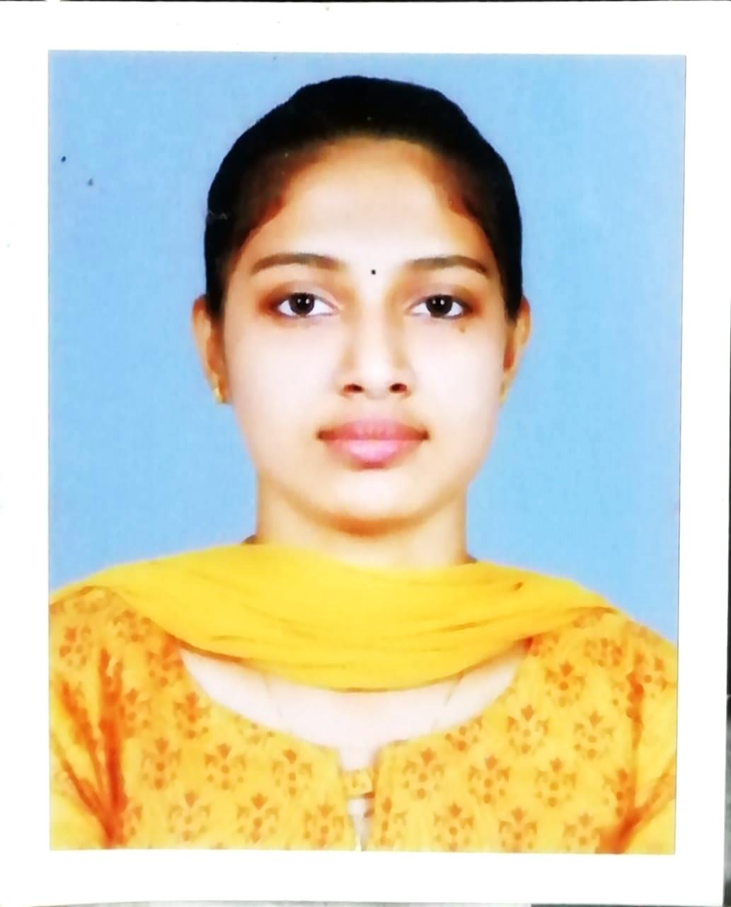
NIMMY BENNY
Mobile: +91 8075170181
bennynimmy21@gmail.com
Present Address:
Onasseril House
Thiruvaniyoor P.O
Thiruvaniyoor
Pin:682308,Ernakulam
OBJECTIVE
To develop my knowledge, skills & my passion as my career & at the same time to be resourceful to the organization and so as to gain expertise with time to become a leading professional in the same.
PROFESSIONAL EXPERIENCE
Professional Experience

- Period : 15 October 2018 – 15 October 2019
Organisation : Sree Abhirami Hospital , Sundarapuram,Coimbatore.
Position : Internship – BSC Physician Assistant
ACADEMIC PROFILE
Education Level | Institution | University/Board | Marks(%)
BSc Physician Assistant | Sree Abhirami College , Sundarapuram,Coimbatore | Dr. MGR University | 77%
Plus two | Fatima Matha HSS,Piravom | State Board Of Higher Secondary Education | 82%
SSLC | GHSS Poothrikka | State Board Of Secondary Education | 83%

STRENGTHS
Hard working, adaptive to any situation, good communication and co ordination skills, initiative, attentive to details and familiar with cross cultural environment.

HOBBY
Listening to Music, Reading , Watching Movies, etc….
PROCEDURES HANDELED

. Suture removal
. Foleys catheterization
. Nebulization
. Supra pubic Catheter change
. IV cannulation

ASSISTING DOCTORS IN PROCEDURES LIKE :--

. Ureteric stent removal
. Cystoscopy
. Bladder wash
. Dilatation
. Endoscopy
. Colonoscopy
. Sigmoidoscopy
. Echo
. TMT
. Renal aspiration
. Trochar cystostomy and Urinary divertion
. Ascites fluid tapping

SKILLS

. Preparing and maintaining patient medical records
. Collection and documentation of patient’s information
. Can record blood pressure and vital signs
. Administering injections

TRAININGS ATTENDED

. Medical coding :-for 3 months (vision health solution,Coimbatore)

SEMINAR ATTENDED

. CARDIO TECH_2019 (Vivekanandha medical care hospital,Namakkal, Tamilnadu)

PERSONAL INFORMATION

Name Nimmy Benny
DOB : 04/06/1997
Age : 22 year’s
Sex : Female
Nationality : Indian
Languages known : English, Malayalam and Tamil
Marital Status : Single
Father's Name : Benny Paul
Religion : Christian

DECLARATION
I hereby declare that the above information are true and correct to the best of my knowledge .If I am given an opportunity to serve in your organization,I assure to do my best with commitment,zeal and loyalty.

Place : THIRUVANIYOOR
Date : 01/11/2019 NIMMY BENNY

