Anoop Ashraf
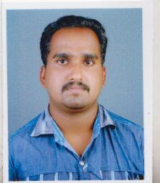
ASHAN THARAYIL HOUSE
CHERAVALLY,KAYAMKULAM. P.O,
ALAPPUZHA DIST,KERALA STATE,
INDIA – 690502
Phone: 8111830311
Email id: anupayoob@gmail.com

Post Applied For: Radiographer

Objective
Looking forward an organization that offers a challenging and stimulating learning environment to work in and provide for individual and organizational development with long term development and career growth.

Education
- +2 from Board of Higher Secondary Exams, Kerala State
- Diploma In Radiographic & Imaging Technology from Punjab Technical University
Faculty Experience
Now worked as a Radiographic Trainer at Edujobs(Skill India Pradhan Mantri Kaushal Kendra Alleppey)

Work Experience
- Worked as X-Ray Technician (Computerised) in Doctor’s Diagnostic Clinic, Haripad, Kerala from 20th November 2011 to 25th August 2012
- Worked as X-Ray Technician from September 2012 to June 2013 in Medivision Laboratories, Mavelikkara, Kerala.
- 2 years experience Metro Scans & Laboratories, karunagappally, Kerala .
- 1.5 years wishwas diagnostics ,karunagappally.
- 1 year experience Vivid Diagnostics Kochi.Alpha hospital

Experienced In
MRI 1.5 Tesla GE Signa Excite
Multi Slice CT Scan GE Hi-speed NX/i
X-Ray GE 500 MA
Computerised Radiography (Fuji System)
Digital O.P.G
E.C.G

General Experience
- Hospital Reception

Personal Details
Date of Birth : 24/06/1990
Sex : Male
Marital Status : Married
Father’s Name : Ashraf E.

