CURRICULUM VITAE
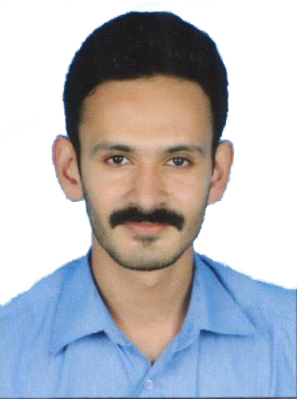
Name: ARAVIND K. M.
Lab technician
Department of transfusion medicine,
Regional Cancer Center, Trivandrum, Kerala.

Age: 29; Date of Birth: 22/01/1990
Father’s name: Muraleedharan nair
Mother’s name: Jayakumari.B.S
Nationality : Indian

CONTACT DETAILS
Mr. Aravind.k.m
Aravindam, Pirappancode.p.o,
Venjaramoodu, Trivandrum
Phone: 9447794162, 8848800364
Email ID: smearu@gmail.com

CAREER OBJECTIVE
A graduate, hardworking, self motivated and responsible with an articulate and outgoing personality. Enjoys meeting new challenges while remaining confident and good tempered under pressure. An individual who adapts well to new situations and can effectively work as a team member. Seeking a challenging carrier in a reputed organization where I could bring out and exploit the best out of my professional ability in respect and thereby helps in broadening and enhancing my current skills and knowledge.

EDUCATIONAL QUALIFICATION
- Plus Two from Janatha H.S.S., Theempamoodu, Kerala Board of Higher Secondary Examination in March 2007
- S.S.L.C from Darsana English Medium Higher Secondary School Nedumangadu, Thiruvananthapuram, Kerala Board of Public Examination in March 2005.

PROFESSIONAL QUALIFICATION
B.Sc Medical Laboratory Technology, University College of Medical Education, Gandhinagar Centre, Kottayam, Kerala.

DURATION OF COURSE : 4 Years (2007-2012)

COMPUTER SKILLS
Packages : Diploma in Desk Top Publication
Operating Systems : Windows (98, 2000 & XP)

TRAINING DURING THE COURSE
- State Public Health and Clinical Laboratory, Trivandrum (16-05-2009 to 14-07-2009)
- Matha Hospital, Thellakom, Kottayam (10-05-2010 to 20-06-2010)
- Modern Diagnostic Center, Mangadu Building, Kottayam (20-06-2010 to 10-07-2010)
- Matha Hospital, Thellakom, Kottayam (13-09-2011 to 03-11-2011)
- Regional Cancer Centre, Trivandrum (01-02-2012 to 15-02-2012)

WORK EXPERINCE
- Worked as Lab Technician Trainee in Well Care Lab & Diagnostic Center, Medical College, Gandhinagar Post, Kottayam
- Worked as Lab technician in Sree Gokulam Medical College and Research Foundation (about one and half years), Venjaramoodu,Thiruvananthapuram.
- Worked as Lab technician in Regional Cancer Center( Bone Marrow Transplanting Unit) From 23-04-2014 to 14-07-2015.
- Specially experienced in doing Autologus and allogenic stem cell apherisis and cryopreservation of stem cells.
- Worked as lab technician in Regional Cancer center in Clinical lab services From 08/08/2015 to 31/03/2016.
- Worked as Apherisis technician at KIMS hospital Trivandrum from 01/04/2016 to 08/07/2018.{EXPERIENCED ON THERAPEUTIC PLASMA EXCHANGE and Autologus and allogenic stem cell apherisis and cryopreservation of stem cells.
- Worked as lab technician at RCC Trivandrum from 16/07/2018 to STILL CONTINUING.
REFERENCE
- Mrs. Sagi Anil, Head of the Department, B.Sc MLT, School of Medical Education, Gandhinagar, Kottayam - Phone : 09447914112
- Dr.Geetha Narayanan,
Head of Department of medical oncology, Regional Cancer Center, Trivandrum.
Phone : 0944750092

- Dr. Vijayalekshmi
Head of department of transfusion medicine
Regional cancer center, Tivandrum
Phone:09497470669

DECLARATION
I do hereby declare that all the entries made above are correct to the best of my knowledge and belief. I bear the responsibility for the correctness of the above mentioned particulars.

Place : Thiruvananthapuram
Date : 24/10/2019 ARAVIND K. M.

