ASHLY K P

KAPPILAMMOOTTIL HOUSE
THOKKUPARA PO
THOKKUPARA
IDUKKI DISTRICT
KERALA- 685565 Email ID: ashlyachu77@gmail.com
Mobile :8281327886

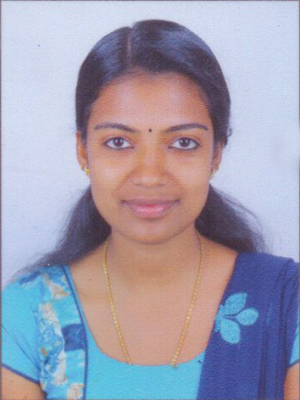

CAREER OBJECTIVE…….

Being a professional Nurse, I would like to sharpen my existing knowledge, skills and be a helping hand to the need one in order to provide effective, comprehensive and holistic care for the patient. My ultimate aim is to develop skills and competence and keep abreast with the recent changes that occurring in the nursing and related field.

CAREER SUMMARY……….

- A patient oriented and caring professional with excellent patience and remarkable organizing skills possesses 5 years Experience as a Nurse.
- Proved loyalty and knowledge of medical ethics.
- Proven record of reliability and responsibility.
- Possess special sensitivity to meeting different needs in varied situations.
- Establish contacts with patients, family, staff and physicians.

ERSONAL QUALITIES………..

- Remain calm and professional throughout critical incidents.
- Excellent in communication skills in written and verbal both.
- Resourceful problem solver capable of implementing solutions to complex problems.
- Ability to work in pressure situations.

PERSONAL DETAILS………...

- Date of birth : 5th march 1997
- Sex : Female
- Marital Status : unmarried
- Nationality : Indian
- Religion : Roman Catholic
- Languages : English, kannada, Hindi, Malayalam & Tamil
- Height : 160 cm
- Weight : 49Kg

Course | Name of the School | University/Board | Years
S.S.L.C | St.Sebastian High School Thokkupara | State board | 2012
Plus Two | G H S S Kunjithanny | State board | 2014

EDUCATIONAL QUALIFICATION…………

PROFESSIONAL QUALIFICATION…………

Name of the Profession | Name of the School | Year
B.sc Nursing | Ashwini college of Nursing Tumkur Karnataka | 2018

WORK EXPERIENCE……………

- Six months Clinical Experience

REFERENCE………..

- Dr. Allwin
General practitioner
Dr+ Family Health Care
Thokkupara po
Thokkupara
Idukki District
Mob; 9947378176

- Dr. Abil Ansari
Diabetologist
Dr+ Family Health Care
Thokkupara po
Thokkupara
Idukki District
Mob ; 9895822836

DECLARATION

I hereby declare that the above mention information is correct up to my knowledge and I bear the responsibility for the correctness.

Yours Sincerely,

Place: Adimaly

Date: 01- 05-2019 Ashly k p

