SCURRICULAM VITAE

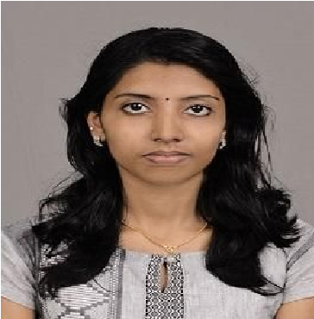 |  | NEETHU .RAJ. S
SREENILAYAM(H)
PATHAMPUZHA.P.O, POONJAR SOUTH
,KOTTAYAM, KERALA , INDIA
PIN: 686582
E-mail:​neethuoct12@gmail.com
Mob:+91-​9496979765​, +91 6238837482

CARRIER OBJECTIVE
Passionate about Dietetics and seek to develop a career in the field of dietitian

MSc(Food science and Nutrition)

2017

St. Teresa’s College, Ernakulam

BSc Clinical nutrition and Dietetics

2015

Alphonsa college, Pala

Class XII

2012

S.M.V.H.S.S, Poonjar

Class X

Class X

2010

St. Antony’s .H.S.S, Poonjar

SPECIALIZATION
*Food science and Nutrition​ *Clinical nutrition and Dietetics

WORK EXPERIENCE
- Worked at Dr.Mohans Diabetes speciality centre
- Worked as a Dietitian at VLCC wellness centre ,Cochin
- I have undergone a one month Dietetic internship on both PSG Hospital, Coimbatore ( 15.4.2016 to 15.5.2016 ) and Lisie Hospital, Ernakulam (01.09.2014 to 30.09.2014 ) as a part of my curriculum.

ACHIEVEMENTS
➢ World Record on Longest line of egg salad

LANGUAGES KNOWN
 | Languages | Speaking | Writing | Reading
 | Malayalam(Mother tongue) | Good | Good | Good
 | English | Good | Good | Good
 | Hindi | Good | Good | Good

TECHNICAL SKILLS
▪​Microsoft office pack (Excel, Word & PowerPoint)
▪​Driving car

Personal Details
▪▪​Age-24 years Date of birth-26-11-1994
▪​Religion-Hindu, Nair
▪​Blood group- O+ve

DECLARATION

I hereby declare that all the information given above is true to the best of my knowledge

Place : POONJAR ; KERALA
NEETHU RAJ S

