- CURRICULUM VITAE

MANJU JOHN  VAZHAPPILLY (H)  CHENGAL KALADY P O  ERNAKULAM  KERALA PH: 7560823832  PIN: 683574 email:manjujohn85@gmail.com | 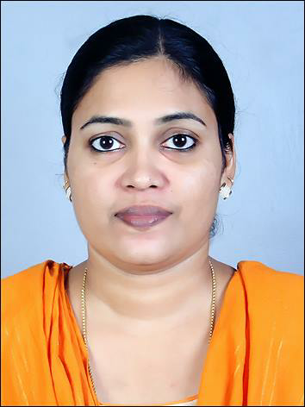

Objective:
To utilize my knowledge and potential to work in growth oriented, leading organization, where professionalism and perfection is respected and which provides ample opportunity of continuous learning, growth and advancement. I believe in the magic of hardwork, and I wish to give my best to the organization for which I work.

Knowledge and Abilities:
Ability to work hard as a team member as well as independently.
- Strong interpersonal skills and Self-starting and highly self motivated.
- Ability to deal with people diplomatically.
- Ability to deal & resolve the regulatory issues in the specified time frame.
- Know well regarding the dispensing of medicines & computer billing.
- Knowledge about the contra indications,adverse reactions,drug interactions.
- Ability to deal all the duties of a pharmacist.

Educational Qualifications:

2014 : Bachelor of Pharmacy
Institute : College of Pharmaceutical Sciences
Cheruvandoor, Kottayam.
University : Mahatma Gandhi University, Kottayam, kerala,India
Division :

2003 : Higher Secondary (12th)
School : Sree Narayana Higher Secondary School Okkal P O
Kerala .
Board : Board of Higher Secondary Education Kerala,India
Division

2001 : Secondary Education (10th)
School : St.Joseph's Girls High School Chengal Kalady P O
Kerala
Board : Kerala State Board, SSLC
Division

Field of Interests

Regulatory Affairs

Work Experience
I have worked as chief Pharmacist in Sarvodaya Medicals Manjapra from 1st of July 2014 to 30th August 2017.

Current Status
Working as pharmacist in P M M hospital Chengal Kalady

Personal details

Name : Manju John
Father's Name : John V S
Permanent Address : Vazhappilly (H)
Chengal Kalady P O,
Ernakulam Kerala Pin : 683574

Date of Birth : 16-03-1986
Nationality : Indian
Marital Status : Married
Language Known : English, Malayalam,Hindi.

References

Mr. Johney Vadakkumcherry
President
Jeevagram
Manickamangalam, P O kerala.
Ph:09447777947

Declaration: I hereby declare that the above written particulars are true to the best of my knowledge & belief

MANJU JOHN

