CURRICULUM VITAE

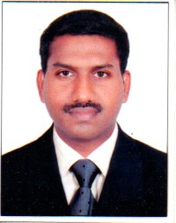

MOHAMMED SIDDIQ.A.A.
ALLUKKARAN HOUSE, MADAVANA ROAD,
DARUSALAM LINE, PACHALAM (PO), ERNAKULAM
PIN-682012

MOB:+91 9745131786 , 9846059007
E-mail: muhammed8910@gmail.com

ACADEMIC QUALIFICATION

- S.S.L.C. from Board of Examination ,Kerala
- PLUS TWO from Board of Examination, Kerala
- B.A. Economics ,M G University
- GDIT Computer course , Kerala
. MBA (Hospital Management) Doing
.
Professional Experience :
- Satkriya Healthcare Innovations PVT LTD, Since 10th Aug 2016 to 6th Jun 2019.
Designation: Clinic Manager
- 1 Year experience as Credit Card Executive. In SBI
- 3 Year experience as Two wheeler sales. in ICICI Bank
- 7 Year experience as Car sales. In Hyundai

PERSONNEL DETAILS

Father's name : Abdul Rahman .A.M
Date of birth : 12/10/1983
Nationality : Indian
Religion and caste : Muslim
Marital status : Married
Gender : Male

Driving Licence: M/c with GR, LMV, 3 WHLR,
HPMV, HGMV
Passport : Validity 08/10/2015 to 7/10/2025

Langauages known

English : Read, Write, Speak
Malayalam : Read, Write, Speak
Hindi : Read, Write, Speak

Declaration

I hereby declare that all the details given above are true to best of my knowledge and belief

Place : Ernakulam
Date :

MOHAMMED SIDDIQ

