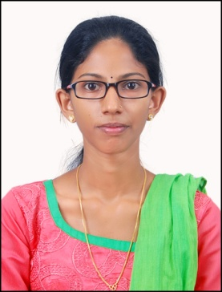  Email:-veenaps222@gmail.com  Address for Communication:-  VEENA P.S  ChamakkalaPuthenpurayil(H)  Mannanam P.O Kottayam  Contact: 9526375261  Local contact:9495664372  Personal Data  Date of Birth :17/8/1995  Age : 24  Sex : Female  Nationality : Indian  Religion : Christian  Marital Status: single  Mother tongue: Malayalam  Father’s name: Sabu Joseph | RESUME  Objective.  To work in a Hospital as nurse which provides a challenging work environment and allows me to grow both professionally and as an individual for the betterment of human species and environment.  Academic Qualifications  Completed Bsc.Nursing from School of Medical Education Institute of Nursing Education Gandhinagar,Kottayam.During this period I got clinical posting at Govt.Medical College Hospital Kottayam  Course Name of Board/University % of marks scored Year of Passing  10th State Board of Examination, Kerala 83% 2011  PLUS TWO Department of Higher Secondary Education, Kerala 76% 2013  Bsc.Nursing Mahatma Gandhi university First year Second year Third year Fourth year 62% 66% 68% 67% 2017  KNMC Register No: KL03201804369  Voluntary Work Experience  - Working as a registered nurse (Voluntary) at Governent Medical College Hospital Kottayam in Ortho- Surgery immediate post operative ward  From- 28/07/2018 To-27/07/2019  Projects & Internships  - Conduct a Research on “Urinary Tract Infection among adolescent girls at St.Philomenas GHS Arpookara,Kottayam  Extra – Curricular & Volunteer work  - Have participated in medical camp at college level  - Have participated in ACLS & BLS , Infection Control and patient care programme at Government medical college hospital Kottayam.  Positions /Responsibilities held  - Was a member of Red Cross Society  Skill set  - Internet Usage  - Computer proficiency (Ms office, MS Word, PowerPoint)  Language Proficiency  English : Read, Write & Speak  Malayalam : Read, Write & Speak  Hindi : Read, write & Speak  Reference  Mrs.Sapthami R.S.  Lecturer of Institute of Nursing Education  School of Medical Education.Gandhinagar  Kottayam  Mob:9895250422  Declaration  I hereby declare that the information given above is true to the best of my knowledge and belief.  VEENA P.S.

