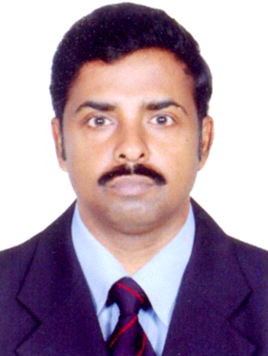
CURRICULAM VITAE

MANIKANDAN P.
Parambath House
Kololamba P.O.
Malappuram Dist.
Mob: 9048393249
Kerala – 679 576

CAREER OBJECTIVE

To be an integral part of a result oriented, reputed and recognized organization, which will utilize my professional skills and ability and will also make me grow along with the organization. My long-terms career goal is to be one of the most competent individual in my area of interest and responsibilities.

ACADEMIC QUALIFICATION

SSLC from the Board of Secondary Education, Kerala in the year 1985

PROFESSIONAL QUALIFICATION

Diploma in Pharmacy from KLE College, Bangalore
Board of examination authority- Govt. of Karnataka in the year 1991.

WORK EXPERIENCE

Presently working as a PHARMACIST at Al-Shifa medical center, Koppam since 2018.

Worked at P.K.Das Institute of Medical Sciences, Vaniyamkulam from
2016 to 2018.

Worked as PHARMACIST at Prayathna Medicals, Edapal from 1996 to 1999.

Worked as PHARMACIST at Saradhi Medicals, Edapal from 1991 to 1996.

PROFESSIONAL STRENGTH

Hardworking, positive mental attitude, punctual, good communication skills,
well versed in the field of pharmacy, etc.

LANGUAGES KNOWN

English & Malayalam

PERSONAL INFORMATION

Father’s Name : Velayudha Kurup C.K.
Age, Date of Birth : 49, 16th February 1968
Sex : Male
Religion : Hindu
Nationality : Indian
Marital Status : Married

PASSPORT DETAILS

Passport No. : H 1503363 Place of Issue : Malappuram
Date of Issue : 17/12/2018 Date of Expiry : 16/12/2028

DECLARATION

I hereby declare that the above mentioned statement is correct & true to the best of my knowledge and belief.

Place : Edapal MANIKANDAN.P

Date : ‎15/06/2019

