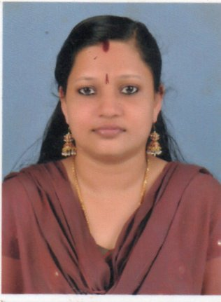  GOPIKA GOKULAN  Personal Data:  Date of Birth: 19-01-1986  Age: 32  Sex: Female  Nationality: Indian  Domicile of: Kerala  Marital Status: Married  Religion : Hindu  Father :Gokulan. M  Mother :Vijayalakshmi  Address :  Chingapurath House  Kaippattoor P.O.  Arakunnam  Ernakulam  Kerala.  Pin: 682 313.  Contact No’s:  9495161893  +919895534130 (Husband)  Email:gopikagokulan@gmail.com  HOBBIES AND INTERESTS:  - Enjoying Music  - Traveling  Linguistics:  1) English &Malayalam (Read, Write & Speak) | CURRICULUM VITAE  CAREER OBJECTIVE  Seeking a career in a reputed organization to become a successful professional and to work in an innovative and competitive environment as a contributing member with commitment & dedication; Where my educational & experience potential meets the needs of the industry.  PERSONAL TRAITS  - Well organized, self-motivated.  - Good interpersonal skills, quick to establish relationship with others.  - Friendly with positive attitude, hardworking, dedicated and able to work at all levels of an organization.  - Willingness to learn new things  SUMMARY OF QUALIFICATION  - Bachelor of Science  St Peter’s College, Kolenchery  Mahatma Gandhi University  Year of Passing: 2008  - Higher Secondary Education:  Fathima Matha English Medium HSS, Piravom  Board of Public Examination.  Year of passing : 2005  - Secondary School Leaving Certificate (SSLC):  Fathima Matha English Medium HSS, Piravom  Board of Public Examination.  Year of passing: 2002  - Medical Transcription:  e-DSS Solutions, Kadavanthara, Kochi  STRENGTHS  - Timekeeping  - Dedication  - Team-player  - Flexible to any working conditions  - Confident  - Communication Skills  EXPERIENCE  - As a medical transcriptionist in Precission Solutions, Kadavanthara from 2008 to 2010  - Medical Transcriptionist in Transcribe Info, Tripunithura from 2010 to 2013  - Quality Analyst in Hashroot Tecnologies, Infopark, Kakanad from 2013 to 2014  - Medical Language Specialist in Nuance Transcription Services India Pvt Limited from 2014 to 2017  DECLARATION  I hereby declare that the information furnished above is true & correct to the best of my knowledge and belief.  Date :  Place : Ernakulam,Kerala GOPIKA GOKULAN

