CURRICULAM VITAE

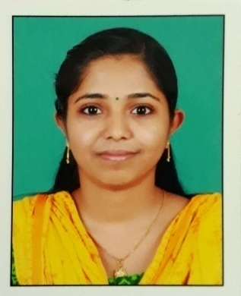

ALISHA SHIBY
Ayathupadathu ( H)
Koduveli (P.O)
Anikuzha
Idukki Kerala – 685581
+91-8078731227(M)
alishaannalisa96@gmail.com

CAREER OBJECTIVE:
To achieve success through hard work & perseverance & establish myself in the Medical Commerce.

EDUCATIONAL DETAILS:

Examination | Discipline/  Specialization | College | Board/  University | Year of Passing | %
B.Sc. | Nursing | Aswini College Of Nursing, Guntur | NTR University of Health Sciences | 2017 | 65%
XII | Bio-Maths Stream | St. Marys HSS, Kaliyar | Higher Secondary Board Kerala | 2013 | 66%
X | S.S.L.C | St.Sebastian’s H.S. Neyyasserry | Secondary Board Kerala | 2011 | 73%

REGISTRATION
Kerala Nurses And Midwives Council Register No: KL04201901705

PROFESSIONAL EXPERIENCE
- One year worked as a Staff Nurse in General ward (medical & surgical) in MAXCURE HOSPITALS (Sahrudaya Health Care Private Limited) from 23rd February 2018 to 27th March 2019.

PERSONAL PROFILE
I am enthusiastic to render a qualitative nursing care. I am also confident to take up responsibilities on my own accord. I am a dedicated registered nurse with good communication skills. I consider nursing as a noble profession and it is a honour for me to take care of the patients.

PERSONAL PROFILE:

Date of Birth : 08/02/1996
Father’s Name : Shiby Joseph
Mother’s Name : Rani Shiby
Gender : Female
Marital Status : Single
Nationality : Indian
Religion : Christian
Languages known : English, Hindi, Telugu And Malayalam
Hobbies : Reading
Permanent Address : Ayathupadathu House
Koduveli (P.O)
Anikuzha, Idukki - 685581
9400091227

EXCELLENT KNOWLEDGE OF BASIC NURSING FUNCTIONS AND SKILLS

Nursing Duties in Emergency Department
- Trauma management
- Receiving patients
- Stabilizing cervical spine with rigid collars
- airway management with oxygen deliver

Management of Cardiac emergencies
- Receiving patients
- Cardiac monitoring with monitors
- Oxygen administration
- Obtain and interpretation of the ECG
- Administrations of drugs according to the doctors order

Care of patients with acute medical conditions
- CPR
- Airway management
- Assessing Glasgow coma scale
- Oxygen therapy
- Trauma management
- Management of cardiac problems

Nursing duties in ICU
- Receiving post operative cases from operation theater
- Assessment of Vital signs
- Planning and implementation of patient care (including Hygiene, Nutrition, Comfort Measures, Elimination needs)
- Following physician rounds and carrying out the orders prescribe
Other type of cases handled
Endocrine : Diabetes Mellitus, Hyper and Hypo Thyroidism
Respiratory : Upper Respiratory Ttract Infection, Lower Respiratory Tract Infection
(Bronchitis, Pneumonia) Tuberculosis, COPD
Infections : MRSA, Fungal Infections, Malaria, Typhoid
Gastro Intestin : Gastrits, Gastric, Duodenal & Peptic ulcers
Neurological : CVA Complications, Epilepsy, Meningitis

Managerial Skills

- Orientation of patients & relative about the hospital and its functioning
- Preparation of emergency drugs & emergency trays for use ( Intubation tray, catheterization tray, Aspiration sets, Gown pack)
- Maintenance of environment hygiene
- Asepsis &Infection control
- Maintenance of Records &Reports
- Maintain ward records & reports
- Maintain ward inventory indents

DECLARATION:
I hereby declare that the above furnished details are true to the best of my knowledge.

Place : Thodupuzha
Date : 18/09/2019 ALISHA SHIBY

