BIO-DATA
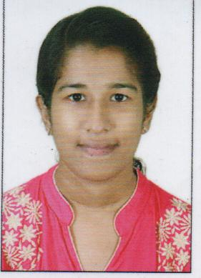
NEEJA ROSE VARGHESE
KUNNACKALAYA KOTTAKKAL HOUSE
THIRUMOOLAPURAM PO
THIRUVALLA
PATHANAMTHITTA
KERALA ,INDIA
PIN:- 678214
MOB:- 9539893555
Email Id : nijarv1995@gmail.com

PERSONAL PROFILE

Father’s Name : K J Varghese
Sex : Female
Date of Birth : 28/04/1995
Religion : Christen
Caste : RC
Nationality : Indian
Marital Status : Unmarried
Languages Known : Malayalam , English
COURSE NAME | BOARD/UNIVERSITY | YEAR OF PASSING
SSLC | Board of Public Examinations, Kerala | 2010-2011
Plus Two | Board of Higher Secondary Education, Kerala | 2012-2013
B.Sc MLT | Kerala University of Health science | 2013-2017
WORK EXPERIENCE
- 1 year Working as Laboratory technician in mother care hospital Vattampalam
DECLARATION

I hereby declare that the above mentioned information are true and correct to the best of my knowledge and belie

Place : Mannarkkad NEEJA ROSE VARGHESE
Date :

