RÉSUMÉ

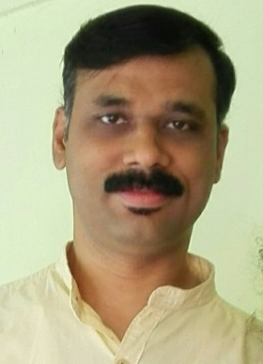
DEEPAK B.
Dakshina
Njakkanal PO
Krishnapuram, Alappuzha (Dist)
KERALA - 690533
Mob# 9645 660255 / 9061 230119
e-mail: deepakdakshina@gmail.com

CAREER OBJECTIVE

To acquire and gain more knowledge and refine myself through interpersonal alliance within and outside the organization, and support the firm to achieve its organization goals.

PROFESSIONAL EXPERIENCE

Around 15 years of experience as a Medical Transcriptionist/ Proofreader in various organizations with exposure to different medical specialties including Cardiology, Pulmonology, Gastroenterology, Urology, Neurology, Radiology & Oncology, OB/GYN, Urgent Care/ER, etc.

Three years of experience as an HR Assistant/Computer Operator at Videocon Appliances Ltd, Aurangabad, Maharashtra.

QUALIFICATIONS

Medical Transcription Course (Mapro Transoft, Pune, Maharashtra)

T.H.S.L.C. (Technical Education Department, Kerala)

Diploma in Computer Applications, NICT, Kollam.

D.B.A. (Diploma in Business Administration), AIIMS, Chennai

PERSONAL PROFILE

Date of Birth : 25/05/1975

Father’s Name : K. Bhaskaran

Marital Status : Married

LINGUISTIC ABILITY: Malayalam, English, Hindi

INTEREST/HOBBIES: Reading, Music, Movies, Social work.

