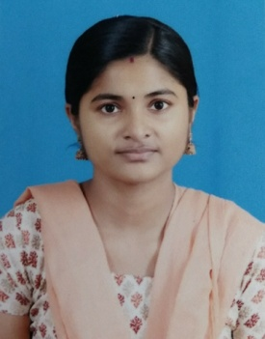
RESUME
PERSONAL DETAILS

Name : Deepthi Laksmy G
Spouse’s Name : Rahul P R
Date of Birth : 26-06-1989
Sex : Female
Religion : Hindu
Mother Tongue : Malayalam
Nationality : Indian
Languages Known : English,Hindi, Malayalam
Permanent Address : Parattu house
Perunna P.O
Changanacherry, Kottayam (Dist)
Kerala
Contact No. : 9744180406 / 8921742695
Email : deepthilakshmy22@gmail.com
Marital Status : Married

OBJECTIVE:

To obtain a position as a Registered Nurse that will foster growth and allow me to apply my clinical and interpersonal skills.

EDUCATION:

Bachelor of Science in Nursing [RGUHS]
Athena college of Nursing
Falnir road, Mangalore, Karnataka

PROFFESSIONAL EXPERIENCE:

Registered Nurse ONCOLOGY department [21-10-2014 to 05-01-2018]
Aditya Birla Memorial Hospital, Pune

Key Skills:

- Ability to monitor cancer patients physical conditions and symptoms.
- To start and maintain peripheral IV’s, implanted ports, PICC lines.
- To administer all chemotherapy drugs and blood products according to protocol.
- Care of patients in Radiation Therapy.
- Prioritize and adjust daily tasks in medical setting by performing daily patient assessments.

Conference/Workshops attended:-

- National conference on “Emerging trends in nursing education” organized by M.Sc Nursing students of Athena Institute of Health Sciences, Mangalore.
- Workshop on “Trends and issue in nursing” organized by 4th year B.Sc Nursing students of Athena Institute of Health sciences, Mangalore.
- Panel Discussion on “Gender inequalities and women empowerment” organized by 4th year B.Sc Nursing students of Athena Institute of Health Sciences, Mangalore.

References:
- Mrs. Arya Kulkarni
Nursing Superintendent
Aditya Birla Memorial Hospital
Pune
Mob: 9881123071
- Mr. Manoj Shankar Prbhu
General Manager
Operational wing
Aditya Birla Memorial Hospital
Pune
Mob: 9527394440

Declaration:

I honestly declare that above written particulars are true to the best of my knowledge and belief.
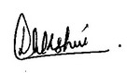
Deepthi Lakshmy G

