CLINICAL DIETITIAN

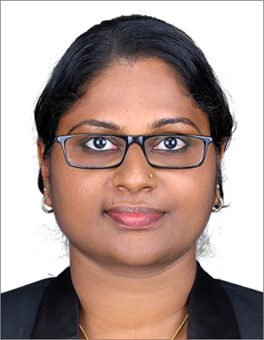

SARITHA SOMAN
Clinical Dietician
Contact No. : +91 9656545717
Email id : saritha.anoop1@gmail.com
Skype Id : SARITHA DIETICIAN

Education : M.Sc. Food and Nutrition
Specialization : Dietetics, Therapeutic Nutrition, Public Health Nutrition, Advance Food Science, Metabolic syndrome
Experience : 10 years
Language known : English, Hindi, Malayalam, Tamil, Arabic
Credentials
- M.Sc. in Food and Nutrition, 2008, St Teresa’s College, Ernakulum, MG University, Kottayam
- B.Sc in Family and Community Science, 2006, St Teresa’s College, Ernakulum, MG University, Kottayam
Professional Associations
Life Member of Indian Dietetic Association (IDA)

Experience
- Working as Clinical Dietician MCCM THQ Hospital, Pathanamthitta , Govt. of Kerala a multi-specialty hospital since 2018, March to till now.
- Worked as dietician Armed Force Hospital, Muscat, Oman, from Feb 2013 to July 2017 under Renaissance Group
- Worked as Dietician, Al Rustaq Hospital, Muscat, Oman, from June 2011 to June 2012, under Renaissance Group
- Worked as Dietician cum Fitness Trainer Jaison’s Fitness First, Cochin. May 2010 to May 2011
- Worked as Dietician cum Fitness trainer, Lifestyle Fitness,Thrissur, December 2009 to May 210
- Worked as Dietician, Fitness Forever, Kakkanadu , 2009 for two months
- Worked as Dietician, Maverick Fitness, Madurai, January to June 2009

Certificates and Training
- Certificates of Training in Codex General Principle of Food Hygiene and Application of HACCP Based Food System.
- Certificates of Fruits and Vegetables Preservation and Nutrition, Food and Nutrition Board, Government of India
- Participation in State Level Seminar on FOOD, HEALTH & DISEASES
- Certificate in Food Safety in, Level 2, certified by CIEH Training Center, Muscat, Oman
- Certificate in Food Safety in Catering, Food Safety Academy and National Hospitality Institute, Ministry of Oman
- Certificates of Participation in Entrepreneurship Development Program on SOY, American Soybean Association
- Training attended on Infection Control. Ministry of Oman
- Participation in XL Annual National Conference of Indian Dietetic Association, 2007

Personal and Contact details:
Date of birth : 07/04/1985
Age : 34 years
Marital status : Married
Address : Parassiniyil House, Mamala P.O, Thiruvankulam, Ernakulam,
Reference

- Dr. Sambu Namboothiri
Suprintendent Medical Officer
MCCM Taluk Headquarter Hospital
Ranny. Kerala
Mob: 91 9809754850

- Amal Al-Taei
Senior Clinical Dietitian,
Armed Force Hospital
Muscat, Oman
Mob : 0968 99326963
Email id : amal.al-taei@hotmail.com

- Mr.Binu John
Location Manager,
Tawoos Industrial Service Company LLC, Oman
Mob: 0968 99019467

Declaration
I hereby declare that all the information mentioned above is true to the best of my knowledge.

SARITHA SOMAN

