From,
Shany Mathew
Vattakunnel House
Velliyamattom P O
Pin: 685588
Idukki, Kerala

TO,
RESPECTED SIR / MADAM,

SUB: APPLICATION FOR POST OF MEDICAL LABORATORY TECHNOLOGIST

I am a graduate in BSc .Medical Laboratory Technology from St. John’s Medical College, Bangalore currently looking for a suitable placement .I completed my internship on June 2019 IN ST.JOHN’S MEDICAL COLLEGE,SARJAPURA ROAD,BANGALORE (Having a 6 Month clinical experience after the completion of my graduation, From :22/12/18-22/6/19) .
I am absolutely sure that there would be extremely challenging and growth oriented career opportunities existing in your organization. All these therefore positively motivated me to explore an appropriate opening with your good self.
May I request you kind favour to provide me an opportunity to work with your esteemed organisation where I promise to work to the best of my ability for the firm and its name.

Kind find my resume attached here with your kind perusal.
Expecting your positive returns in this regard,
I remain,
Yours Sincerely,

SHANY MATHEW
RESUME
SHANY MATHEW
MEDICAL LABORATORY TECHNOLOGIST
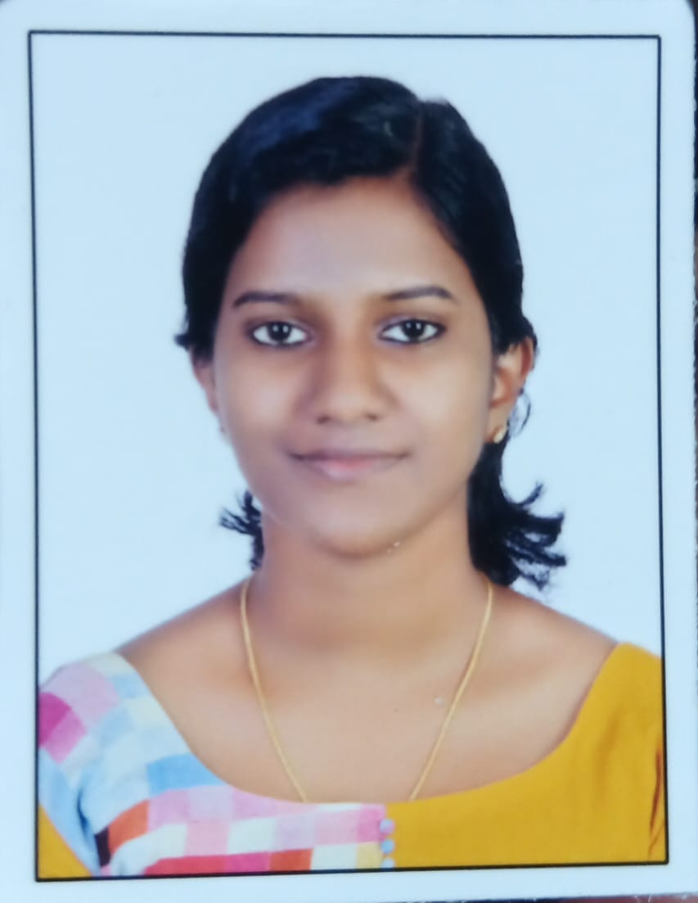

CONTACT INFORMATION
Address : Vattakunnel (H) Velliyamattom P O, Idukki(Dt) pin :685588, Kerala
Mobile No. | :+91 7411164645
Email | :shanysheena12@gmail.com

PERSONAL INFORMATION
Age | : 22 years old
Date of Birth | : 23/12/1996
Nationality | : Indian
Gender | : Female

Objectives:
Obtain a position at a reputable company where I can have a continuous learning and training to enhance my skills, knowledge and experience in relation to professional practice.
Summary of Qualification:
A medical technologist, who is well motivated, determined, with an average computer hands-on experience. Able and qualified to take on responsibilities. Accurate ,reliable, diligent and focused on the timely quality completion of all laboratory procedure and work well under pressure and time constraints.

EDUCATIONAL BACKGROUND
College: ST JOHN’S MEDICAL COLLEGE BANGALORE, INDIA
BSc. Medical Laboratory Technology
Academic years: 2015 - 2018
Secondary: CKVHSS VELLIYAMATTOM
Academic year: 2013 - 2015
CLINICAL TRAINING

ST JOHN’S MEDICAL COLLEGE HOSPITAL
Medical Laboratory Technology INTERN Dec 22 -June 22 Bangalore, India.

DUTIES & RESPONSIBILITIES

HEMATOLOGY
- Phlebotomy
- Do routine hematological examinations such as complete blood count (CBC), reticulocyte count, bleeding time, clotting time, prothrombin time, activated prothrombin time (APTT), erythrocyte sedimentation rate (ESR), and malarial smear.

CLINICAL MICROSCOPY
- Perform routine urinalysis and fecal analysis procedures.
- Perform other special examinations such as pleural fluid analysis, semen analysis, pregnancy test, occult blood test, bile test, and test for ketone.

CLINICAL CHEMISTRY
- Performs quality control program including preventive maintenance in the laboratory using standards, calibrators and controls, and maintains compliance with what the government requires.
- Performs routine and special chemical analysis on blood, as well as chemical test in urine, CSF, and other body fluids using automated chemistry analyzers.
- Do blood chemistry test such as blood sugar test ( fasting, random, 2PPBS, OGTT, OGCT ), lipid profile ( cholesterol, triglycerides, HDL,LDL), blood urea nitrogen (BUN), creatinine, blood uric acid (BUA), LDH, SGPT, SGOT, total protein, albumin, globulin, ALP, bilirubin, CKMB, troponinT, troponinI, sodium, potassium, chloride, calcium, magnesium, phosphorus, and amylase.

IMMUNOLOGY AND SEROLOGY
- Performs quality control, calibration, and running of controls and samples.
- Trained to perform various serological test such as; Widal ,Weil Felix, PaulBunnel, VDRL, TPHA, RA, ASO, CRP, bacterial antigen tests, cryptococcal antigen test etc.
- Rapid test for HIV, HbsAg, Chikungunya, Rota and Adenoids virus. • Various ELISA tests.

MICROBIOLOGY
- Various methods of sample and specimen collection.
- Various culture Technics, including aerobic, anerobic, fungal, mycobacterial culture and automated culture technics
- Various staining techniques like Gram stain, ZN and modified ZN stain, trichrome stain, wet mounts ,KOH preparation, India ink preparation.
- Knowledge and experience in using various culture media and biochemical media and tests for identification and isolation of microorganisms.
- Antibiotics susceptibility test and knowledge on automated Vitek Techniques.

BLOOD BANKING
- Interview and screen possible donors.
- Bleed qualified donors.
- Record and monitor stocks of blood.
- Receive, identify, and recheck blood units from established blood banks.
- Performs blood typing and screening of blood products for transfusion, and performs major and minor cross matching, and antibody screening.

MACHINES HANDLED

MICROBIOLOGY
- BD BACTEC 9120
- Biomerieux mini Vidas
- Biomerieux BACT/ALERT 3D
- Biomerieux VITEK 2 compact
- Biomerieux FilmArray multiplex PCR System
- Aggape mispa i2
- Thermo scientific Phadia 100 .

Biochemistry
- Roche Hitachi COBAS 6000
- ABL 800 basic
- 9180 electrolyte analyzer
- Osmomat 030
- Bio rad variant II
- Advia centaur xp immunoassay I
- Advia centaur xp immunoassay II
- Versa cell
- Dimension exl with LM I
- Dimension exl with LM II
- Immulite 2000
- Cobas e 601
- Cobas e 6000
- Roche Hitachi Cobas e 411
- Interlab- Genio Electrophoresis
- Bio- Rad Variant II TURBO

Haematology

- BACKMAN COULTER LH 500 & 750
- ALI FAX ROLLER 20
- Clinical analyzer 635
- Sysmex XN 3000
- Sysmex XN 1000
- Sysmex XT 4000i
- Sysmex XT 2000i
- ACL TOP 500
- ACL TOP 300
- Sysmex UF- 1000i
- Siemens Clinitek Atlas
Blood Bank
- IH-500 (BIO RAD)
- TERUMO T- ACE II (component separator)

REFERENCES
Dr. SAVITHA NAGRAJ
Professor and head of Microbiology Department
St. John’s Medical College Hospital,
John Nagar, Sarjapur Road,
Bangalore - 560 034,
Karnataka State,
India
PH: +918022065184
I hereby sign that the above statements are correct and true of my knowledge.

SHANY MATHEW

