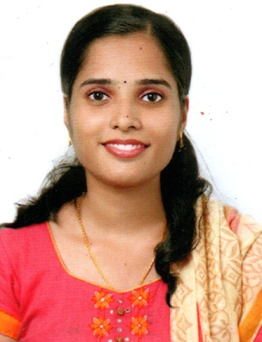
JEENA JOSEPH
MOBILE: + 91 7902855653 Pallivathukkal House
E- MAIL: jeenamariamjoseph@gmail.com Thiruvamkulam Post
Ernakulam Dist 682305

CAREER OBJECTIVE
A Position with a Reputed Hospital where I can utilize the best of skill and abilities that fit to my experience & education. To obtain a challenging position in hospital profession, where I can contribute in different positive way in patient care.
Core Qualifications

- Outstanding front office clerical abilities including typing and answering phones
- Familiar with all MS Office applications including Word and Excel
- Sound ability to resolve client or guest issues in a timely courteous manner
- Excellent relationship-building and communications skills
- Strong time management skills
PROFESSIONAL QUALIFICATIONS
Worked as Administrative staff at Images India Cochin (2015 – 2018)
- Organize and schedule meetings and appointments
- Maintain contact lists.
- Assist in the preparation of regularly scheduled reports
- Develop and maintain a filing system
- Order office supplies
- Contribute to team effort by accomplishing related results as needed

Worked as Front Office Executive at Shriramcity Union Finance Ltd. Cochin
( 2014 – 2015)
- Maintain contact with customers.
- Telephonic contact with customers for developing business.
- Assist in the preparation of regularly scheduled reports.

ADDITIONAL QUALIFICATION

- Certificate Program in Hospital Administration

EDUCATIONAL QUALIFICATIONS

- Successfully completed Bachelor’s degree in Commerce.

SKILLS

- Excellent team work ability to achieve the tasks within the shortest possible time.
- Leadership skills.
- Fluent in English& Malayalam.
- Self-motivated, independent problem solving attitude
- Always willing to learn anything new depending on the requirements
- Ability to grasp new concepts with minimal efforts
- Reading books

Personal Profile
Nationality : Indian
Sex : Female
Religion : Christian
Date of Birth : 23rd January 1993
Marital Status : Married
I hereby certify that the above details given by me are correct to the best of my Knowledge
Date Signature

