CURRICULAM VITAE

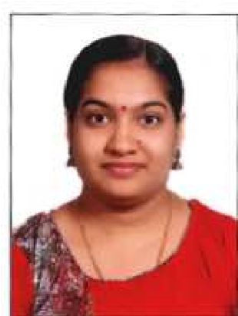
SUMISHA MANOHAR
Sumesh Bhavan Omalloor P.O.
Pathanamthitta Kerala – India
Pin – 689 647
Mob:- 9526353713
Email :sumishalekshmi91@gmail.com

OBJECTIVE AND AIM

My objective is to seek a career in Nursing Profession where individual skills and Interpersonal relationship contributes and serves towards the betterment of the community as a whole. My qualities include having a dedicated, patient and honest approach to the task entrusted on me and a fervent desire to fulfil the same to fullest of my abilities and to the entire satisfaction of each and everybody concerned.
PERSONAL DETAILS

Name | : | Sumisha Manohar
Father Name | : | Manoharan. R
Date of Birth | : | 23/03/1991
Gender | : | Female
Place of Birth | : | Konni
Marital Status | : | Un-married
Religion | : | Hindu
Mother Tongue | : | Malayalam
Languages Known | : | English, Malayalam & Hindi
Nationality | : | Indian
Job | : | Staff Nurse

Passport Details

Passport No. | : | S4159745
Date of Issue | : | 13-08-2018
Date of Expiry | : | 12-08-2028
Place of Issue | : | Trivandrum

ACADEMIC QUALIFICATIONS
Achievements | Year of Passing | University/Board | Remarks
S.S.L.C | 2007 | Board of Kerala, India | 1st Class
Plus Two | 2009 | Board of Kerala, India | 1stclass

PROFESSIONAL QUALIFICATIONS
Achievements | Year of Passing | University/Board | Remarks
B.Sc Nursing | September 2016 | Rajiv Gandhi University,  Karnataka, India, K.N.N College of Nursing Yelahanka, Bangalore | Course Completed

Experience during the course Time
Practical Sessions were at Govt. Hospital Bangalore

EXPERIENCE DETAILS
PERIOD | INSTITUTION | DEPARTMENT
20-02-2017 TO  26-03-2019 | Mount Zion Medical College Chayalode ,Adoor (Pathanamthitta dist) Kerala | Medical and Surgical ward

NURSING DUTIES
As a Staff Nurse in ward management to assist doctors during ward rounds.
Assessing Psychological and Psychological needs of the patient and providing proper nursing care.
Experience in using essential clinical tools such as Blood pressure apparatus, Pulse oximeter, Thermometer, Glucometer etc.
Carrying our necessary nursing procedures such as wound Cleaning and dressing, administration of O2, IV fluids blood transfusion, injections and medications, Bandaging, applying a splint, Nebulization, suction ,bowel wash, enema catheterization etc.
Assisted in Endo tracheal intubations and resuscitation procedures. Care of patients with tracheotomy, poisoning, ventilator etc.
Assisting for lumbar puncture, skin biopsy, paracentesis and thoracocentesis.
Administrating chemotherapy to Leukemia patients. Checking and recording of vital signs.
Monitoring patients with E.C.G Monitor, Cardiac monitors, Ventilators
Preparation of patients undergoing diagnostic tests like X-ray, USG, CT, blood, investigations etc.
Keeping the ward neat and tidy to avoid infection.
Preparation of patients report, record keeping and hand over duties.
Participation in ward teaching.
Meeting hygienic, nutritional and elimination needs of patients.
Explain the discharge advices about medications, rest, diet, exercise, avoidance or unhealthy habits such as smoking, alcoholism and follow up care.

PERSONALITY
I am a conscientious, hardworking and reliable person.
I am also good at communication and enjoy meeting different people.
I am very flexible and can adapt to any working environment.

HOBBIES
Reading to keep knowledge updated
Writing poems.
Gardening
Listening to music
REFERENCE
1, The Principal
KNN College of Nursing Yelahanka, Bangalore
DECLARATION

I hereby declare that all the statements are true and correct to the best of my knowledge and belief.

Place: Pathanamthitta

Date : SUMISHA MANOHAR

