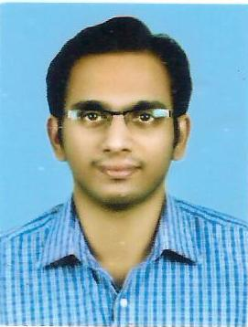
personal details

Name : Shyam Gopal V Age : 33
Sex : Male Marital Status : Married
TCMC Registration number : 41923
Educational Qualification : M.B.B.S , Diploma In Orthopaedics, DNB Orthopaedics
Address : Flat no 103 Natioanl Excellency
Kalavath Road
Palarivattom Kochi
Permananent address : K V Madom
Kandiyoor
Mavelikara
Contact no : 9446085226
E-mail : shyamg911@gmail.com
Languages : Malayalam,English,Hindi

Education DETAILS

2004-2009

mbbs, pushpagiri medical college thiruvalaa

2013-2015

diploma in orthopaedics (d’ortho), government medical college trivandrum

2016-2018
DNB ORTHOPAEDICS,Lisie hospital Kochi

Experience

2013 To 2015

Junior resident department of orthopaedics, medical college trivandrum

october 2015 To jan 2016

junior consultant department of orthopaedics, Matha hospital ettumanoor

march 2016 To march 2018

Junior resident department of orthopaedics, Lisie hospital kocHi

June 2018 to June 2019

Specialist at aster medcity kochi

PUBLICATION

- Atypical Fracture Shaft of Femur Case Series –Kerala journal Of Orthopaedics -2016 Shyam Gopal V et al. Atypical Fracture Shaft of Femur Case Series. Kerala Journal of Orthopaedics 2016;29(1–2):69–73.

- Myositis Ossificans in Carcinoma Stomach – Kerala Journal Of Orthopaedics -2018 Shyam Gopal V et al. Myositis Ossificans in Carcinoma Stomach. Kerala Journal of Orthopaedics 2018;30(1–2):40–42.

- Complex Lisfranc Injury—Case Report Kerala Journal Of Orthopaedics -2018 Shyam Gopal V et al. Complex Lisfranc Injury—Case Report. Kerala Journal of Orthopaedics 2018;30(1–2):52–56.
- Functional outcome of Cemented bipolar hemiarthroplasty in Fracture neck of femur- Prospective study –Kerala journal of Orthopaedics Jan 2018 Shyam gopal V et al Functional outcome of cmented bipolar hemiarthroplasty in Fracture neck of femur Prospective study Kerala Journal of orthopaedics Jan-Jun 2018 ;31(1) :24-30
------------------------------------

