RESUME RESHMA RAMANAN. B
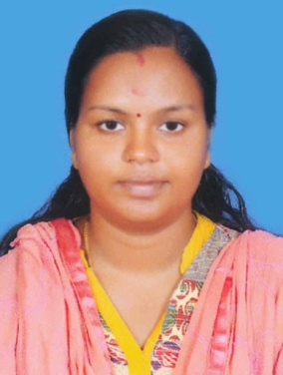
Address: Kaippallil
Pallippattumuri, Thrikkunnappuzha PO.,
Alappuzha (Dist), Kerala (State)
Mobile : +91 9539750568
Email ID : reshma143sarath@gmail.com

CAREER OBJECTIVE
To be employed as a nurse that would allow my utilize the knowledge and skill that gained from school and from the different centres and hospital where I have practices my profession.

PERSONAL DETAILS
Father’s Name : Ramanan
Gender : Female
Date of Birth : 09th November 1994
Religion : Hindu
Nationality : Indian
Marital Status : Married
Language Known : English, Hindi & Malayalam

ACADEMIC QUALIFICATION
Course Passed | Board/University | Year of Passing
S.S.L.C | Kerala | 2010
Plus Two | Kerala | 2012
BSc. Nursing | Kerala University of Health Science | 2016

NURSING REGISTRATION DETAILS
Registered Nurse in Kerala Nursing Council
Reg. No : KL03201703498

WORK EXPERIENCE
- Hospital : Govt. GD Medical Collage, Alappuzha
Position : Staff Nurse
Duration : From 22th July 2017 to 15th November 2018

DUTIES & RESPONSIBILITIES

- Assessment planning implementation & Evaluation of the nursing Care requirements of their allocated patients
- Administrated medications : Orally via NG tubes intravenous subcutaneous
Intra muscular
- Prepare the client for surgery
- Experience in administering total parental nutrition & IV Antibiotics
- Insure Hand Hygiene before and after the procedure and in between patient care
- Prepared patients for emergency surgery for other procedure like CT MRI
- Taking initial ECG tracing
- Taking care of Mechanically Ventilated patients after surgery
- Directly responsible to the doctors to carry out the orders
- Maintaining the different function of all equipments etc.

DECLARATION
I hereby solemnly declare that the information given above in true and correct to the best of my knowledge and belief.

Place : Thrikkunnapuzha
Date : 29/07/2019
RESHMA RAMANAN. B

