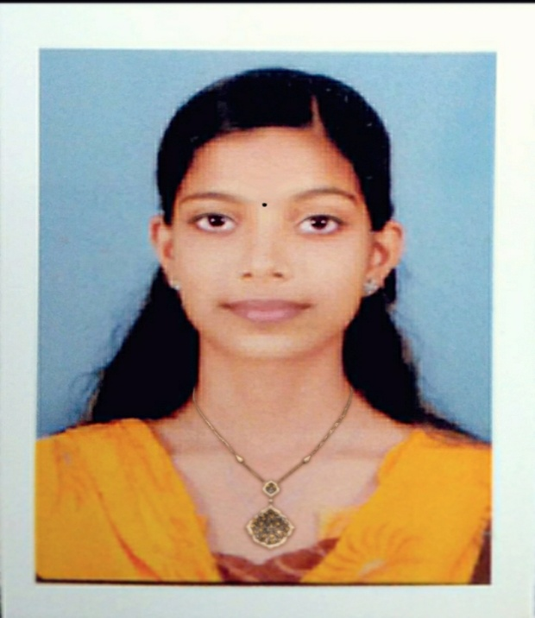
ELSABA MATHEW
D/0 MATHAI K.M
KADAPPILLIL (H) MANNATHOOR P.O
ERNAKULAM DISTRICT
DATE OF BIRTH: 03/10/1996
MOBILE: 9886508024,8547175617
NATIONALITY: INDIAN
E.MAIL:heavenlyangels996@gmail.com
CURRICULUM VITAE

Career Objective
To seek a challenging career to utilize my skills in serving the organization to my best known knowledge and hoping to play an inventive and active role in the organization growth.

Personal Strength

- Can work well as part of a team and independently
- Having effective interpersonal and communication skills
- I am being well organized and efficient in my duties
- Having the desire to achieve both personal and corporate goals

EXTRA AND CO-CURRICULAR ACTIVITES

- Participated in dance and music competition at school and college
EDUCATIONAL Qualifications

Course | School / College | Board/ University | Month and year of passing | Percentage
SSLC | Infant jesus EMHS koothattukulam | Kerala | March 2012 | 95%
PUC | ST.Augustine girls higher secondary school moovattupuzha | Kerala | March 2014 | 80%

PROFFESSIONAL QUALIFICATION

Course | Duration | College | University | Year | Percentage
Bachelor of physiotherapy | 4yrs of full time curriculum  6 month of internship  (2014-2019) | Srinivas college of physiotherapy and research centre, mangalore | Rajive Gandhi university of health science,  bangalore | 1st YR | 73.12%
 |  |  |  | 2nd YR | 67.85%
 |  |  |  | 3rd YR | 72.41%
 |  |  |  | 4th YR | 70%

Handled patients of:

- Orthopedic conditions.
- Neurological conditions.
- Cardio respiratory conditions.
- ICU &Emergency conditions.
- OBG
- Community units.
- Geriatrics conditions.

Conference/workshop attended:

- Participated in mangalore physio con 2017 held at yenapoya University,mangalore.

- Participate as deligate in the CME on ROAD TRAFFIC ACCIDENTS-PREVENT,PREPARE,PROTECT on 2017 in A.J.Institute of medical science & research centre .

- Attended workshop on Basics of ICU Care and Cardio pulmonary Rehabilitation,held at Kanachur Hospital and research centre,mangalore on 15th and 16 ^{th} of march 2019.

- Attended workshop in manual therapy (CMT) an integrated Approach for the vertebral column ,neural tissue,and Extremities from April 2nd to may5^{th,}2019 at MTFI international Training Centre, Mangalore , India.

Additional Qualifications

- Certified manual therapist.

Project work:

- Done project on ‘‘Functional movement screening in physical therapy practice’’.

PROFESSIONAL EXPERIENCE:

Completed 6 months internship at Srinivas College of physiotherapy and Research centre Pandeshwar, Mangalore.

DAYS | PLACE
30 | Chethana Child Developmental Centre
30 | St.Agnes Special School & Casagia Old age Convent
30 | Srinivas Hospital,mukka
30 | Musculoskeletal Department,Srinivas  College,Mangalore
30 | Neuro rehabilitation Centre,Srinivas  College,Magalore
30 | Old age Home( prasanth Nivas)

CAMPS ATTENDED:

- Camp attended in puttur organized by chetana child development centre Mangalore.
- Camp attended in BC Road organized by Chetana Child Developmental Centre, Mangalore
- Camp attended in gurupura organized by Chetana Child Developmental Centre, Mangalore.

Personal traits

- Ability to work in a team and achieve tasks and targets
- Good adaptability
- Punctuality & time management & dedicated

Declaration

I, hereby declare all the above furnished details are true to my knowledge

DATE: 19 /06/2019
ELSABA MATHEW
PLACE: ERNAKULAM

