Aiswarya mk
M.S.W ( Master Of Social Work)
Communication Address | E-Mail ID | Aiswaryamk997@gmail.Com | 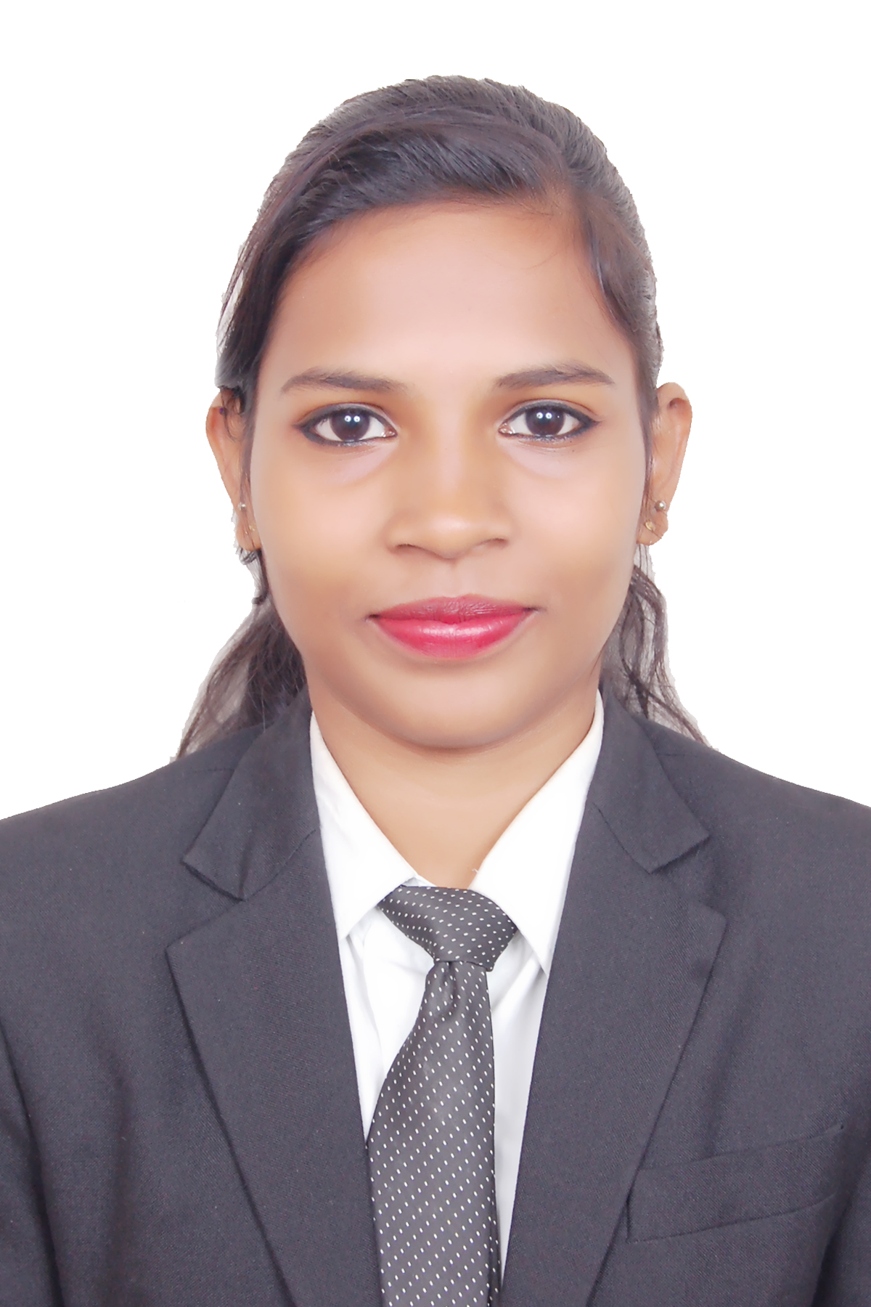
Vageri parambu,MLA Road,kovoor,p.o chevayur  Pin code:673017 | Contact Number | 8129060935
 | Date of Birth | 11 january, 1997

Objective
To obtain employment with a organisation that offers a positive atmosphere to learn and implement new skills and technologies for the betterment of the organization.

Academic Qualification
Course | Institution | University/Board | Year of Passing | Percentage of Marks
MSW | Kristu Jayanti College Bangalore. | Bangalore University | 2019 | (64% - 1st sem)  (67%-2nd sem)  (68%-3rd sem)  (64%-4th SEM)
B.A English Literature with  journalism | Holy cross institute of managment and science | Calicut university | 2017 | 69%
12th Standard | Jdt iqraa higher secondary | Kerala state board | 2014 | 69%
10th Standard | St marys english medium school | Indian Certificate of secondary board | 2012 | 74%

Personal Strengths
Organized & Self Motivated, Adaptable, Willing to Work in a team, Good Listener, Able to work in challenging and stressed Conditions, Good Computer skills, managing change, inter-personal communication, Building relationship, Forward thinking.

Internship
- Completed 25 days of fieldwork in Bosco for the children who are at risk in the city of banglore from 5th september 2017 to 22nd november 2017. Assisted in counselling children and conducted group work, case work and community organisation.
- Completed 25 days of fieldwork in Reaching Hand for the empowerment of women and children from december 12th 2018 to may 7th 2018. Engaged in conducting awarness class on puberty and conducted group work, case work and community organisation.
- Completed 20 days of fieldwork in Aids counselling,care, education and prevention training society (Accept) from 24/07/2018 to 10/10/2018. Assisted staffs, interacted with the patients and conducted case work and group work.
- Completed 21 days of internship(minor project) in living life trust from 22nd may 2018 to 23rd june 2018. Assisted in yoga therapy and interacted with senior citizen.Conducted group work and casework.
- Completed 25 days of fieldwork in spandana hospital from month of october to january. Assisted in conducting yoga therapy, dance therapy, interacted with the psychiatric patients and observed their behaviours
- Completed 30 days of fieldwork in Aster CMI hospital from the month of April 23 to 31st of may . Assisted in legal works if transplant coordinator,counselling,conducted research study.

Academic Projects
Conducted a research on stress, anxiety and depression among the HIV patients.
Worked on a project on social darwanism in the novel call of the wild by Jack london
Active Participation
Participated in a national conference on Green social work: From environmental crisis to ecojustice in collaboration with climate justice(CMCJ) on february 27 & 28, 2018
Participated in a national conference on Disability managment at work: problems and prospects in association with CBM on october 11 & 12,2017
Participated in the workshop on Life skills for social work proffessionals, conducted by the centre for Life skills education( CLSE) from 19th to 22nd july 2017
Participated as a volunteer in lions blood bank on 12/01/2018

Achievements & Awards
Published my research article 'stress, anxiety, and depression among HIV patients' in global development review
Succesfully completed 3 month course of MS Office with internet
Active member in National service scheme (NSS)
Active member in Anti drug organisation (ADSO)
Secured third prize in story writing competition

Computer Proficiency
MS office with internet

Personal details
- Father’s Name Mr. Gopinath mk
- Father’s Designation P.W.D Contractor

- Marital Status Single
- Area of Interest psychatric counselling, child counselling,
- Linguistic Ability English, Tamil, Malayalam
- Nationality Indian
Reference
Dr. Rama Gokula Krishnan
Faculty, Department of social work
St.joseph college,banglore
Ph: 9500518643

Ms Amrutha k
Faculty,department of literature
Holy cross college,Calicut
Ph:9176843788

Declaration
I, Aiswarya MK, Certify that to the best of knowledge and belief, these data correctly describe my qualifications, my experience, and me.

(Aiswarya mk)

