RESUME
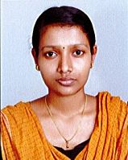
ROSE MARY K.J
Email: jeenarosekj@gmail.com Phone: 8590839276, 7034158188

Phone: 7034158188
Phone: 7034158188

Profile
Completed Diploma in Medical Laboratory Technology in Government medical college. Done special posting in Microbiology, Biochemistry, Pathology and Blood bank. Well confident for doing Laboratory tests.
Academic Qualification

Course | University/Board | Institute | Year of Passing | Percentage
Higher Secondary | Kerala | St. Francis Assisi Higher Secondary School, Arthunkal | 2013 | 80
SSLC | Kerala | St. Francis Assisi Higher Secondary School, Arthunkal | 2011 | 77

Professional Qualification
- Diploma in Medical Laboratory Technology (DMLT)
Institution: Govt. T D Medical College Vandanam, Alappuzha
Result : Passed in first class
Quality-focused medical lab tech with excellent clinical skills gained through hands-on experience. Perform all laboratory tests and procedures with attention to detail and optimum quality. Knowledgeable of state approved medical lab policies, hygiene requirements and general/standard procedures
Medical Lab Experience during course
- Performed automated routine and blood tests.
- Drew samples from patients personally when needed.
- Issued timely and accurate reports based on analysis
Procedural Skills
- Cell Counts
- Urine analyses
- Body Fluid Analyses
- Cytology
- Histopathology
- Serology
- Metabolic & Electrolyte Panels
- Liver, Renal and Thyroid Function Testing
- Blood grouping & Rh Typing and cross matching
- Lipid Profiles
- Routine Cultures
- Diploma in Computer Application (DCA)
Institution: TCIL-IT Education and Training
Operating System Known : Windows XP, 7, 8,10
Programming Languages : C, C++
Application Software : MS Office
Work Experience

- Neethi Labs & Scans owned by Govt. Servants Co-Operatives Bank Cherthala
Duration: 27 March 2017 – 12 January 2019
- Urban Primary Health Centre, Moolamkuzhy under National Health Mission Ernakulam
Duration: 17 January 2019 -30 April 2019
Duties and Responsibilities in lab
- Blood collection
- Routine check-up
- ECG
- BP measuring
- Billing Process
Machine Hands on Experience
- Horiba Yumizen H500 (Fully Automatic 6 Part Haematology Analyzer)
- Dirui CS-T240 (Fully Automatic Bio Chemistry Analyzer)
- MiniVIDAS Automatic Immuno Analyzer
- Quo-Lab A1c (HbA1c Analyzer)
Personal Skills

- Willingness to learn
- Familiarity with medical lab tools
- Fluent with chemicals and their reactions
- Good communication skills
- Good presentation skills
- Able to work in any situation
- Self-motivated personality
- Quick learner
- Hard working

Personal Data
Permanent Address : Kalambukattu House
Arthunkal P.O
Cherthala, Alappuzha
Pin: 688530
Father’s Name : Joy Varghese (Late)
Mother’s Name : Mariamma Joy
Date of Birth : 19/03/1996
Sex : Female
Nationality : Indian
Marital Status : Single

Languages Known

- Malayalam
- English
- Hindi

Interesting

- Drawing
- Ornaments making
- Listening to music

Other Certifications
- Certificate of completion in NSS Programme 2011 - 2013
- Certificate of participation NIST Beauty Show 2017

Declaration
I hereby declare that all the statements made in the above resume are correct to the best of my knowledge and belief.

Place: Arthunkal Yours Sincerely,
ROSE MARY K.J

CERTIFICATES
DMLT
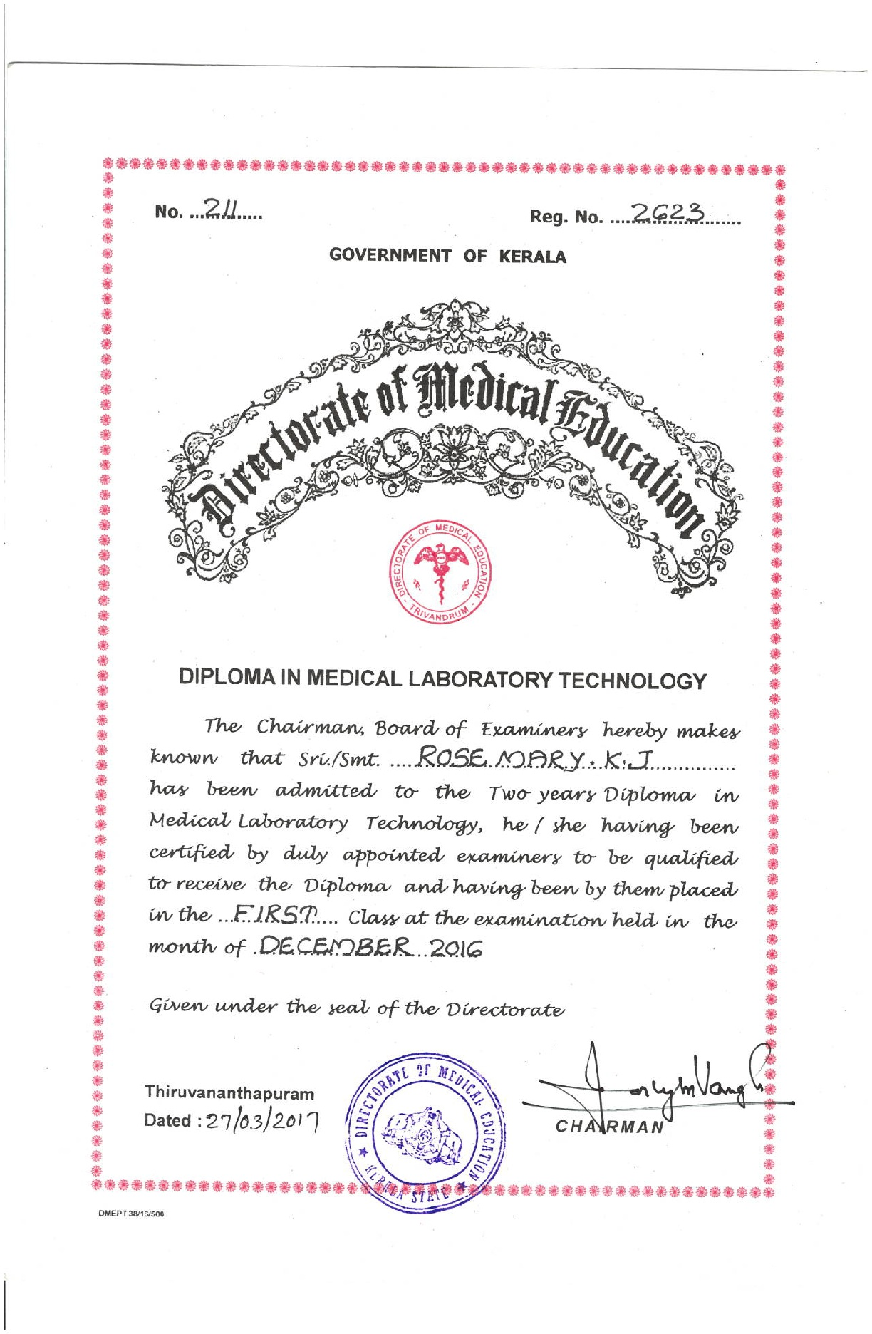
REGISTRATION
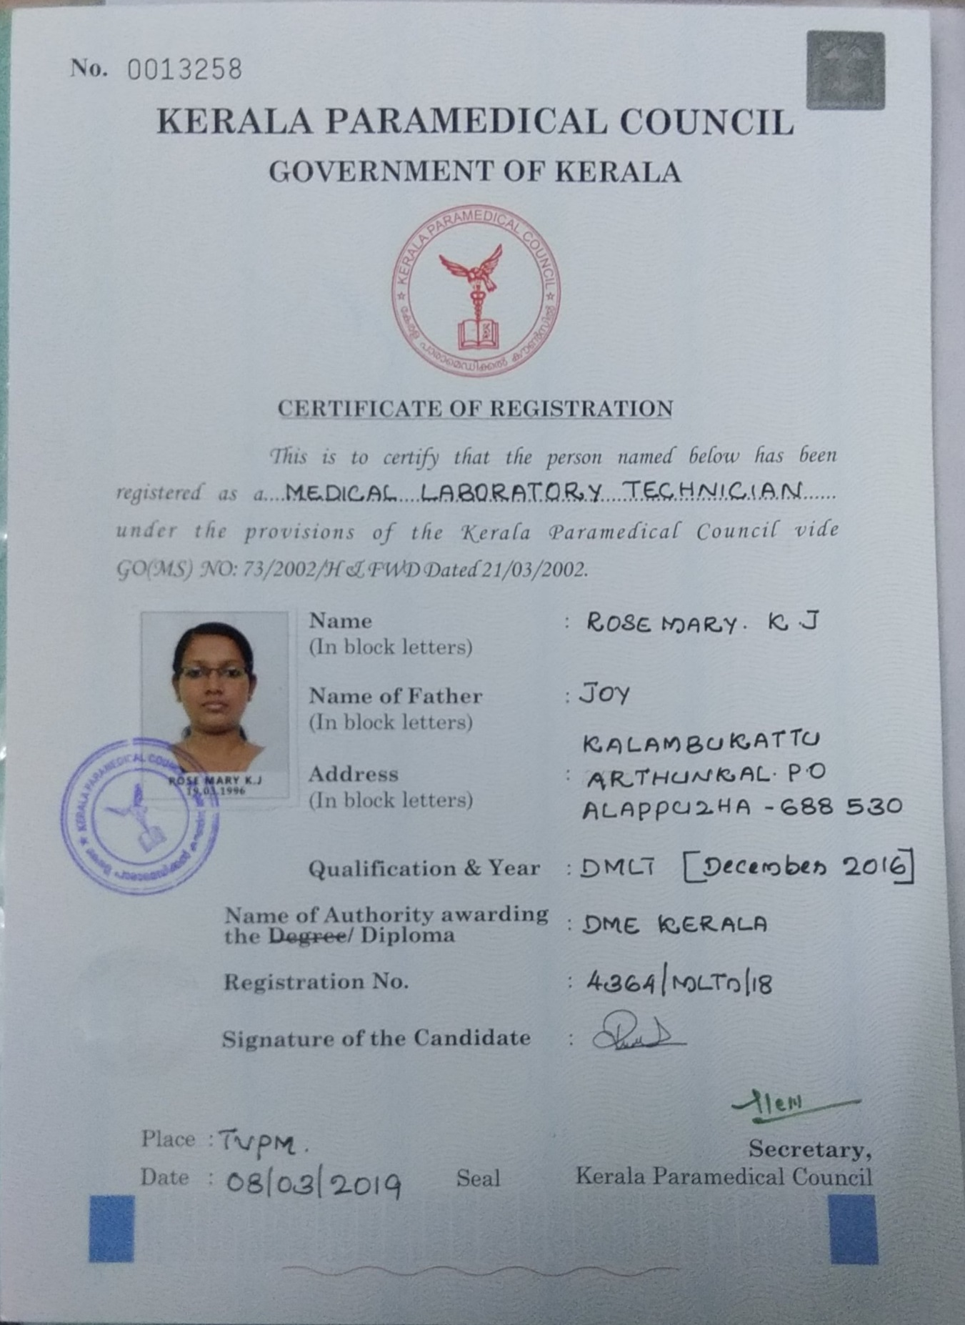

EXPERIENCE
