RESUME
MINNU PHILIP minnuphilipphysio@gmail.com
PHYSIOTHERAPIST +91 9074502515

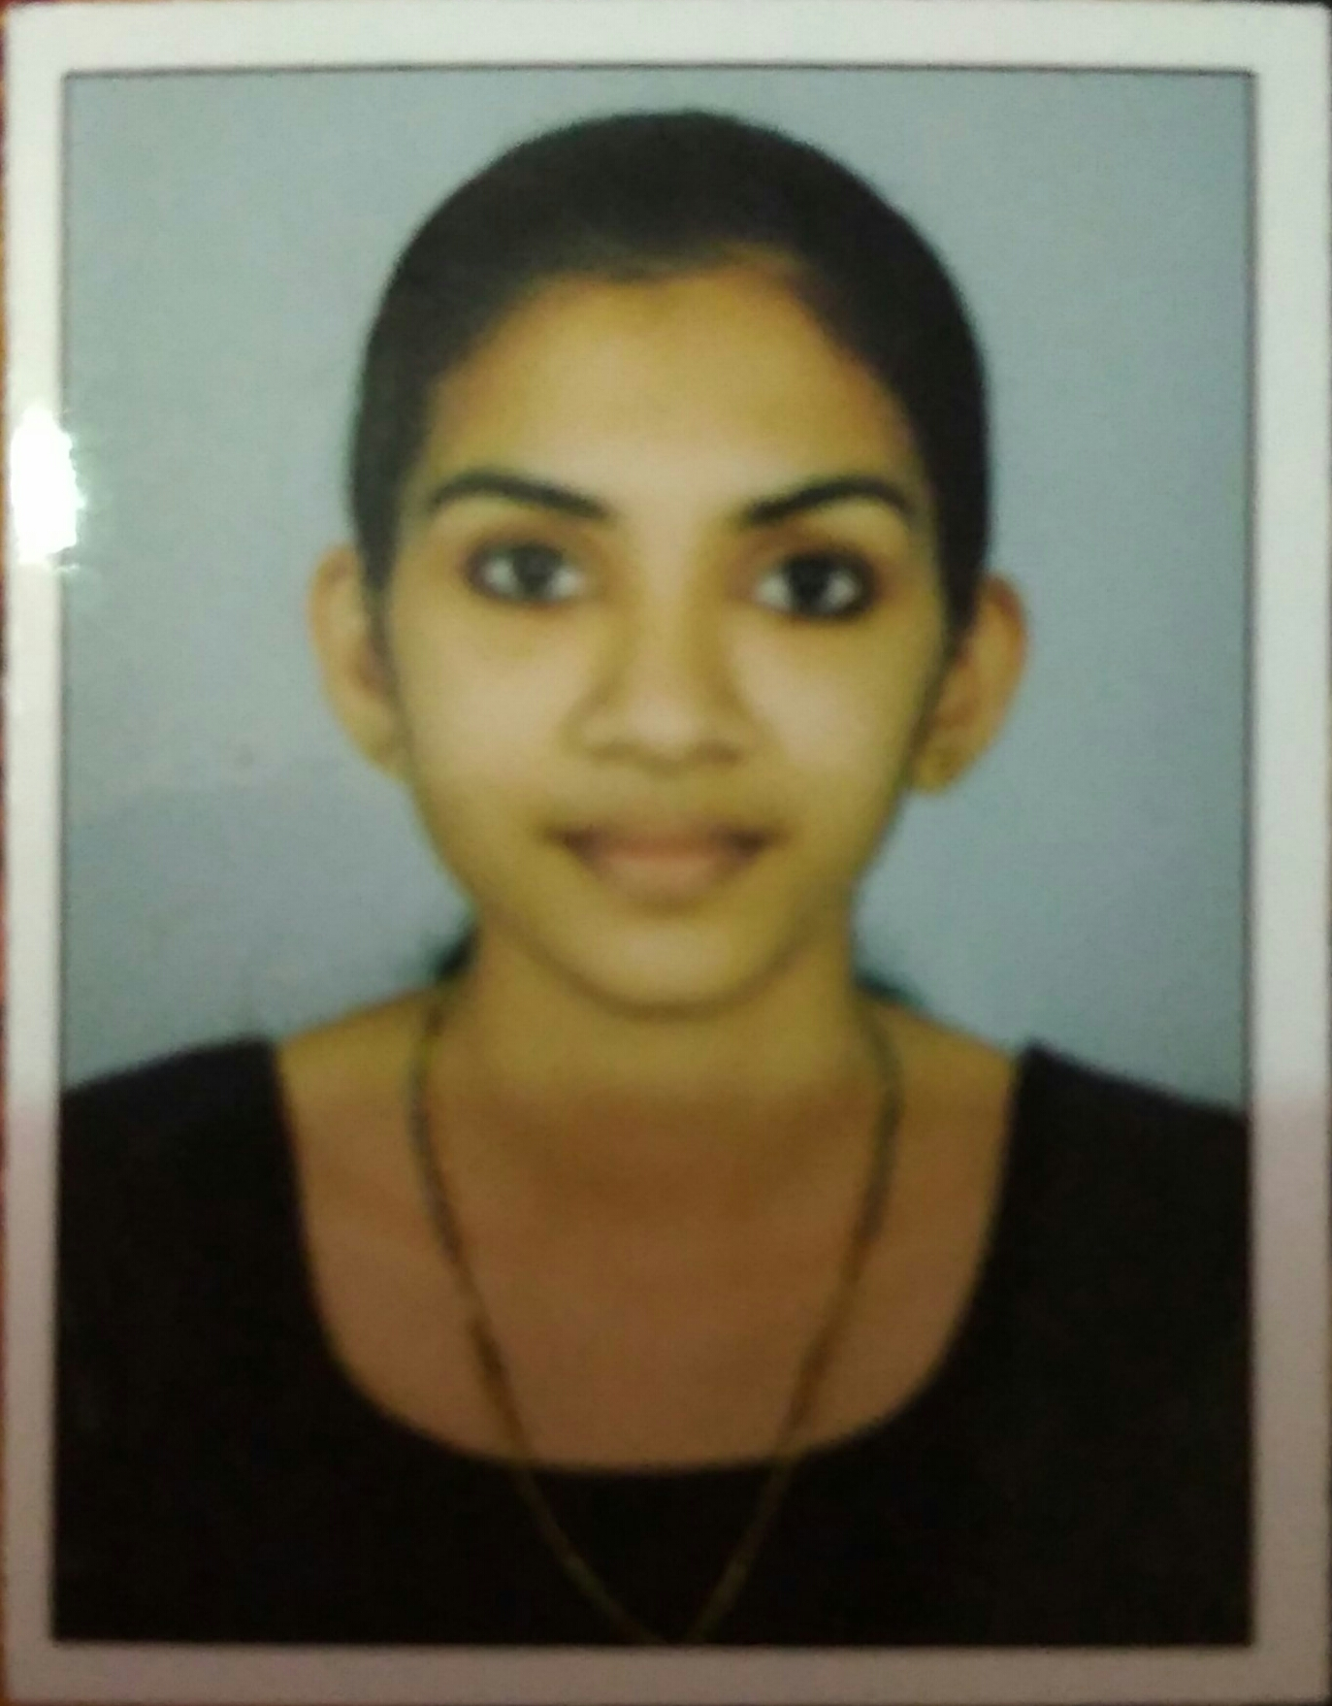
PERSONAL DETAILS
NAME: MINNU PHILIP
DATE OF BIRTH: 26/04/1996
AGE: 23 YEARS
GENDER: FEMALE
MARITAL STATUS: SINGLE
LANGUAGES KNOWN: ENGLISH, MALAYALAM, HINDI
COMMUNICATION ADDRESS: MINNU PHILIP,
PADAYATTY,
THURAVOOR P.O,
THURAVOOR,
ERANAKULAM,
KERALA.
PIN- 683572
PERMANENT ADDRESS: --do- -

PERSONAL SUMMARY:
I am a confident individual seeking an opportunity to work in your esteemed institution to explore my career options. As an active and enthusiastic personality I wish to apply my knowledge which I gathered through my collegiate education and from my Internship period to help individuals to recover from their ailments.
PERSONAL SKILLS

- Professional Mannerisms
- Effective Patient Handling
- Listening skills

EDUCATIONAL PROFILE:
SL  No; | COURSE | BOARD/UNIVERSITY | YEAR OF  PASSING | PERCENTAGE
1) | BACHELOR OF PHYSIOTHERAPY | KERALA UNIVERSITY  LIMSAR COLLEGE | 2018 | 59%
2) | PLUS TWO | KERALA HIGHER SECONDARY  EDUCATION BOARD | 2014 | 75%
3) | SSLC | KERALA SECONDARY EDUCATION BOARD | 2012 | 85%

CORE EXPERTISE:
- Hemiplegia Rehabilitation
- Musculoskeletal Conditions – Conservative/Pre -op/ Post – Surgical Rehabilitation
- Spinal Cord Injury Rehabilitation
- ICU and Critical Care Physiotherapy
Hobbies
- Sports including long and intermediate distance running
- Dancing Western and Classical
- Traveling
REFERENCES
- Mrs. Remya Neelambaran,
Head of the Department,
Physiotherapy Department,
LIMSAR,
Angamali – 683572
Mob: 9567148491
Email id: remyaneelambaran10@gmail.com

- Mr. Vijayan Gopalakrishna Kurup,
Chief Physiotherapist,
Department of Physical Medicine and Rehabilitation,
Rajagiri Hospital,
Chunangamveli
Aluva. 683112
Mob No: 9442132248
Email id: vijayan1978@gmail.com

DECLARATION

I hereby declare that all the information provided here are true to my knowledge.

Thanking you

Minnu Philip

