CURRICULUM VITAE
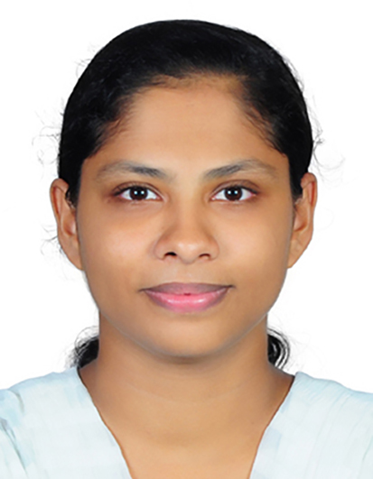
NEENU CHACKO
CHIRAPPATTU (HOUSE)
CHEMMANAD, VARIKOLI P O
ERNAKULAM (DIST)
KERALA, 682308
MOB: 7025377818
EMAIL:neenumolchacko90@gmail.com

OBJECTIVE:
Aspiring for challenging career in nursing profession. Desirous for taking up challenging jobs & executing them in time and to the satisfaction of the client given with a prospective growth in career.

PROFESSIONAL MEMBERSHIP :
Registered with Karnataka State Nursing Council, Kerala Nurses and Midwives Council

DESIRED JOB :
Seeking a permanent position as a Registered Nurse.

EXPERIENCE SUMMERY :
- Five Month Experience in Operation Theatre and Recovery ICU From 03.10.2017 To 28.02.2018, Ernakulam Medical Centre, NH Bypass, Palarivattom, Kochi -682028
- One Year and Four Month Experience in Out Patient Department Since 01.11.2015 To 15.03.2017, Ushus Hospital, T.B. Road, Muvattupuzha – 686661.
- Two Years Experience in Operation Theatre (ophthalmology) and Out Patient Department From 01.10.2013 To 03.10.2015, Medical Trust Hospital, M.G . Road,Ernakulam -682016
- Eleven and half month experience in Gastro Ward From 03.10.2012 To 26.09.2013, P.G. Medical Trust Hospital V.K Road, Nilambur – 679329.

PERSONAL DATA :

Name : Mrs. Neenu Chacko
Father’s Name : Mr. C.P. Chacko
Mother’s Name : Mrs .Sarakutty Chacko
Date of Birth : 12- 06 – 1990
Sex : Female
Marital Status : Married
Nationality : Indian
Religion : Christian
Languages Known : English, Hindi & Malayalam
Permanent Address : Chirapattu (House) Chemmanad,
Varikoli .P.O,EKM, Pin :682308
Height : 159Cm
Weight : 55Kg
Blood Group : O +Ve

