CURRICULAM VITAE

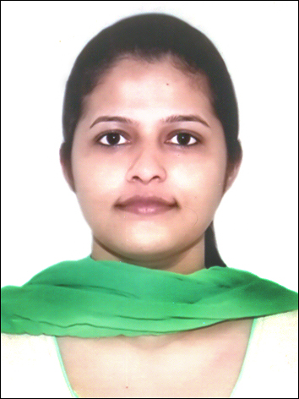

NAME: JINTU MARIA
Address: KOCHUPARAMBIL (H)
ARTHINKAL (P.O) CHERTHALA
ALAPPUZHA (DIST)
KERALA.
CONTACT NUMBER: 9746602800
EMAIL: jintumaria92@gmail.com
EDUCATIONAL QUALIFICATIONS (HIGHEST FIRST)
SL NO | TITLE OF QUALIFICATION | NAME & PLACE OF UNIVERSITY | YEAR OF PASSING
1 | BSc Nursing | College of Nursing ACME Pariyaram Medical College, KUHS University Thrissur | 2011 to 2015
2 | Higher Secondary | St. Francis Assisi H.S.S Arthinkal | 2011
3 | SSLC | St. Mary’s G.H.S Cherthala | 2009

PROFESSIONAL REGISTRATION
SLNO | NAME & STATE OF NURSING COUNCIL | REGISTRATION NUMBER | DATE OF REGISTRATION
1 | Delhi Nursing Council | 63941 | 27/04/2016
2 | Kerala Nurses And Midwives Council, Kerala | KL03201602476 | 25/02/2016

EMPLOYMENT/WORK EXPERIENCE (LATEST FIRST)
SL NO | DURATION OF EMPLOYMENT |  | NAME & PLACE OF HOSPITAL | BED CAPACITY | DEPARTMENT
 | FROM | TO
1 | 30/04/2016 | 16/12/2017 | Fortis Escorts Heart Institute Okhla New Delhi | 310 | Cathlab

PERSONAL PROFILE
Name |  | Jintu Maria
Date of birth |  | 13/12/1992
Gender |  | Female
Name of Father |  | K.A George
Marital status (Married/Single) |  | Single
Nationality |  | Indian
Religion |  | Christian
PASSPORT DETAILS
Passport No: | N 6116328 |  | Date of Issue: | 16/12/2015
Place of Issue: | COCHIN |  | Date of Expiry: | 15/12/2025

REFERE NCE
- Preetha M.K, Principal
College of Nursing ACME
Pariyaram

2 Capt. Sabitha Nath
Nursing Superintendent
Fortis Escorts Heart Institute
Okhla New Delhi 110025

DECLARATION
I hereby declare that the information given in this CV is true and correct.

DATE: NAME: JINTU MARIA
PLACE: SIGN:

