RESUME
.  SNEHA SAJI  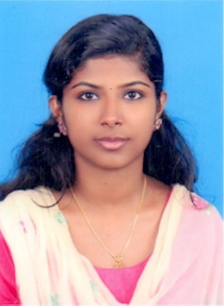  e-mail id:  snehasaji009@gmail.com  Cell No.:9745050791  Present Address  Njaliparambil House  Munnar P.O  Munnar-685612  Languages Known  - English  - Malayalam  - Hindi  Personal Data  DOB : 25-12-1995  Gender : Female  Father’s Name : Saji Thomas  Blood Group : O +  Religion/Caste : Christian / RC  Reference:  Mr. Manu Jose  Associate Professor  Nirmala College of Pharmacy  Muvattupuzha  Cell.no:- 9947938832 | CAREER OBJECTIVES  To begin my job career in a renowned hospital and to gain an exceptional career move ahead through long efforts and performance regularity.  ACADEMIC ACHIEVEMENTS  - B.Pharm–Nirmala College of Pharmacy, Muvattupuzha, Ernakulam  - HSE-Science, 2013 (85%)  - SSLC, 2011 (87%)  EXPOSURE TO INSTRUMENTS  - UV Spectrophotometer  - Spectrofluorometer  - IR Spectrophotometer  AREAS OF INTEREST  - pharmacist  - Patient Counselling.  - Quality control of drugs in pharmacy  - Manufacturing of drug products  - Management of pharmacy  PROJECTS CARRIED OUT:  Evaluation of practicing pharmacy than that of theoretical ideal pharmacy  STRENGTHS  - Eager and willing to add knowledge,base and skills  - Honest  - Hardworking  - Loyal and persistent in work  WORK EXPERIENCE  - Worked as Trainee Pharmacist at Morning Satr Medical Center,Adimali a NBH Accredited Hospital (1 Month)  - Now working as Pharmacist at Jan Aushadhi Adimali Since September 2018

PERSONAL AND PROFESSIONAL SKILLS
- Extensive knowledge of the medicine, compound and their dosage
- Advance knowledge of medical terminologies and concepts
- Good organizational and problem solving skill
- Knowledge of handling of Narcotic medicine

COMPUTER SKILLS
- Microsoft Office (Ms Word, Ms Excel, Powerpoint)
- Internet Borwsing
DECLARATION
I hereby declare that the above information are true to the best of my knowledge and belief.

Place : Munnar SNEHA SAJI
Date :

