CURRICULUM VITAE

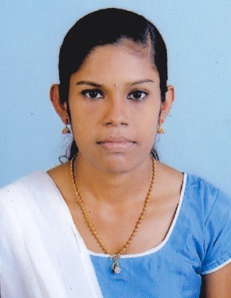  VAISHNAVI BABU  E-mail:vaishnavibabu1998@gmail.com  CONTACT ADDRESS:  Babu Nilayam  Kadakkarapally.P.O,  Cherthala, Alappuzha(Dist.),  Kerala, India.Pin:688529  Mobile: +91 8089946900  PERSONAL DATA:  Date of Birth : 12-03-1998  Sex : Female  Marital Status: Single  Nationality : Indian  Father : Babu.V.P  Mother : Athira Babu  Mother Tongue : Malayalam  Languages Known :  English, Malayalam & Hindi | VISION & OBJECTIVE:  To prove myself dedicated, worthy and energetic in a progressive organization that gives me scope to apply my knowledge and skills and be a member of a team, which dynamically works towards success and growth of the organization.  ACADEMIC QUALIFICATIONS:  - 2016-2019 BCom COMMERCE WITH COMPUTER APPLICATION  NSS College, Cherthala  - 2014-2016 PLUS TWO: HSS KANDAMANGALAM, Cherthala  - 2013-14 TENTH LEVEL: St.MARY’S GHS, Cherthala  ADDITIONAL QUALIFICATION  - Certificate Course in Computerized Accounting in Tally  - Certificate Course in Advanced Computer Operation  (Windows, Word, Excel & Power Point)  WORK EXPERIENCE:  NIL  HOBBIES  - Reading  - Music  - Cooking

PERSONAL SKILLS:

- Co-ordination skill,
- Comprehensive problem solving ability, `
- Willingness to learn new skills & techniques,
- Ability to deal diplomatically and friendly with people.

COMPUTER SKILLS:

Software’s:

TALLY, HTML, MS- WORD, MS- EXCEL, MS- POWER POINT

DECLARATION:

I solemnly declare that, the above statements made by me in this form are correct to the best of my knowledge and belief.

Date:
Place: CHERTHALA VAISHNAVI BABU

