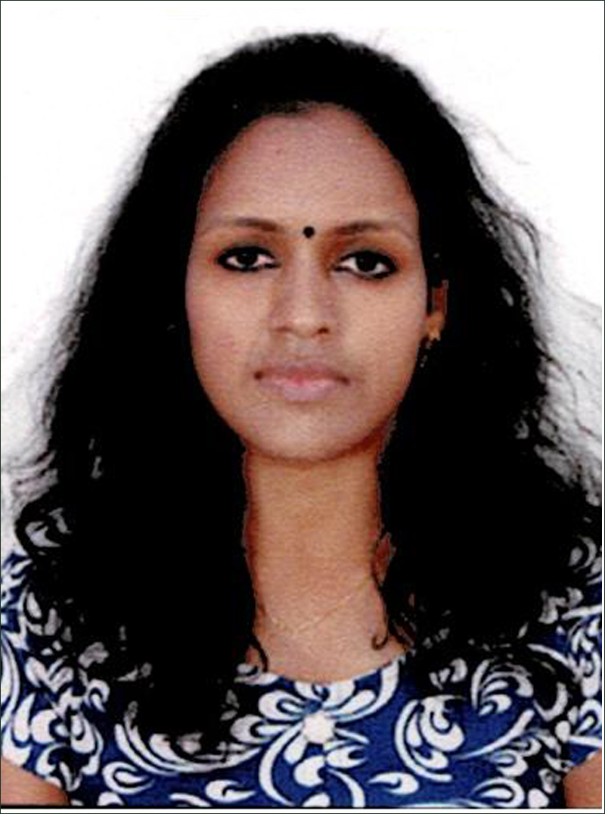
CURRICULUM VITAE

PRASEETHAMOL VASUDEVAN
Kochidappallikkalayil (H)
Punnathura (W) P.O
KOTTAYAM- 686632
Email id: praseethamalu89@gmail.com Mob: 9946215216

OBJECTIVE

To gain exposure to new challenges in Clinical Nursing Field and contribute whole to the welfare of society through my skill and knowledge.

PERSONAL PROFILE

Name : Praseethamol Vasudevan
Father's name : E.K. Vasudevan
Date of Birth : 28-02-1989
Age : 30 years
Gender : Female
Nationality : Indian
Religion : Hindu
Marital status : Single

LANGUAGES KNOWN

To Write : English, Hindi, Malayalam
To Speak : English, Hindi, Malayalam
To Read : English, Hindi, Malayalam
ACADEMIC QUALIFICATION
Course | Board / University | Year | Percentage
GNM | KPM Hospital, Pvt.Ltd, Malappuram , Kerala | 2009-2013 | First Class
Bsc.Botany | K.E. College Manannam, Kottayam, Kerala | 2006-2009 | First Class
VHSE | VHSE Kanakkary, Kottayam, Kerala | 2004-2006 | First Class
SSLC | GHSS Ettumanoor, Kottayam, Kerala | 2004 | Third Class

EXPERIENCE
Course | HOSPITAL | Status & Specification | Year | Experience
STAFF NURSE | ORCHID Hospital, Downhill, Malappuram | Medical & Surgical Ward | 21-09-2013 to  02-05-2019 | 5 year & 7 months

DUTIES AND RESPONSIBILITIES
- Working as a staff nurse
- Taking over from on duty staff, checking and recording of inventory of equipments and medicines, assessing and condition of the patient.
- Identify the ECG rhythms and monitoring telemetry
- Care of narcotic drugs
- Excellent communication and interpersonal skills with the ability to demonstrate.
- Care of narcotic and controlled drugs
- Followed infection control policies and procedures.
- Preparing patients for various diagnostic procedure
- Preparing and administering medications
- Maintaining patients documents.
- Assisting with activities of daily living
- Pressure care
- Guiding and assisting student nurse in the bedside
- Maintaining fluid and electrolyte balance
- Great ability to deal with the queries and problems.
- Excellent communications and interpersonal skills with the ability to demonstrate.
- Develop report with patient, family, staff, and physicians.
- Relate well to people from a variety of culture
- Preparing and administering medications
- Handling RTA patients.
- Handling neuro patients and stroke patients.
- Blood transfusion giving property after checking the blood group and cross matching blood group, correct serial number and expiring date.
- Provide all comprehensive nursing care to all operated patients.
- Managing patients with various medical and surgical conditions
- Followed infection control policies and procedures.
- Maintaining fluid and electrolyte imbalance.
- Preparing and administering medications.
- Assist doctors for procedures eg. Intubation, Lumbar puncture.
- Assisting patient’s home status and organizing support if need.
- Checking observation and making sure patients vital care stable.
- Care of patients with central lines
- Care of elderly and disable patients.
- Monitoring patients closely and effectively
- Responsible for ensuring safe manual handling techniques/ use of movable and fixed hoist.
- Discharging and following of care

CLINICAL PROCEDURE
- IV cannulation
- Assisting lumber puncture
- NG tube insertation and removal
- Urinary catheter insertation
- Glucose check using glucometer
- Using cardiac monitor
- Administering medication
- Looking other pre & post operative patients
- Assisting to daily living activities
- Usage of safe technique infection control policies and protocol
- Prepare & calculating all medicines.
- Safe handling and record of drugs.

EQUIPMENTS USED

- Suction apparatus
- Pulseoxy meter
- Glucometer
- Dressing trolly

STRENGTH
- Urge to learn new technical skills
- Good communication skills

REFERENCE
- Dr. P.C. Joseph MBBS, MD 2. Ms. Kadeja ( Reg No. 493)
Senior Consultant Physician & Endoscopist Nursing Superintendent
Ph: 2734048 Orchid Institute of health Care
& Research Pvt. Ltd. Malappuram
DECLARATION

I hereby declare that the information furnished above is true to the best of my knowledge and belief.

Place: Kottayam
Date: PRASEETHAMOL VASUDEVAN

