CURRICULAM VITAE

SHILPA ANJALASSERY SANTHOSH

B.A (ENGLISH LITERATURE),
DIPLOMA IN COMPUTER APLICATION
E-mail: shilpasanthosh9889@gmail.com
VYPIN, ERNAKULAM
Cell: +917994466457
+917559020721

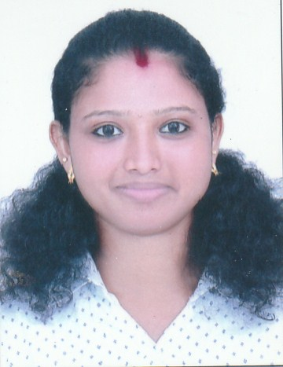

CAREER OBJECTIVE

1.Exceptional customer service and administrative abilities
2.Excellent communication with the public, supervisors & peers
3.Expertise in electronic mail and office suite software, such as Microsoft Outlook and Corel Word Perfect
4.Proficiency in database user interface and query software, such as data entry software and claims processing system software
5.Knowledge of record and file management systems

PROFESSIONAL AFFLIATIONS AND CERTIFICATIONS
Graduation in BA ENGLISH LITERATURE (2018)
Successfully completed DIPLOMA IN COMPUTER APLICATION (2019)
PERSONAL STRENGTH

- Excellent in communication skills in written and verbal both
- Ability to work in pressure situations
- Honesty and Sincerity
- Enjoys challenges and responsibility

KEY ADMINSRATION SKILLS

- Effective communication, interpersonal and organizational skills.
- Capable to adapt new techniques.
- Able to maintain and deliver the responsibilities.
- Excellent data entry skills.
- Good multi-tasking abilities
- Good interpersonal skills and the ability to function as a team member

IT KNOWLEDGE

- Packages : MS- Office & Tally

ACADEMIC HISTORY

YEAR | COURSE | UNIVERSITY | INSTITUTIONS
2013 | SECONDARY SCHOOL LEAVING CERTIFICATE | KERALA STATE BOARD | GVHSS NARAKKAL  KERALA, INDIA
2015 | VOCATIONAL HIGHER SECONDARY EXAMINATION | BOARD OF VHSE | GVHSS NARAKKAL  KERALA, INDIA
2018 | BA ENGLISH LITERATURE | MAHATMA GANDHI UNIVERSITY | VIDYANIKETHAN COLLEGE , KERALA, INDIA
2019 | DIPLOMA IN COMPUTER APPLICATION | KERALA STATE RUTRONIX | LEADERS ACADEMY OF COMPUTER EDUCATION NJARAKKAL

WORK EXPERIENCE

Year | Job | Company | Duration
2018 | As a data entry operator | Sheduled Caste Development office  (Under State Government) | 1 Month

PERSONAL PROFILE

Name : Shilpa Anjalassery Santhosh

Gender : Female

Marital Status : Married

Spouse Name : Predhweeraj Cheerassery Balaji

Languages Known : English, Malayalam & Hindi

Nationality : Indian

Declaration:

I hereby assure you that all the details and particulars mentioned above is accurate and to the best of my knowledge.

Shilpa A.S

