Haritha Pushpan

Thuruthiparambil House, Junior Janatha Road, Vyttila P.O., Pin Code -682019

Mob: +91-8138 847626 | Email: harithapushpan357@gmail.com

Objective
To work for an organization, where I can utilize my knowledge for the organization’s growth and move ahead in carrier by providing me interesting carrier opportunities and harness the best of my carrier.

Education

COURSE | NAME OF INSTITUTE/UNIVERSITY | YEAR
M.com Finance | M.G University | Pursuing
B.com Computer Application | St. Paul’sCollege, Kalamassery | 2017
Plus Two | St. Theresa’s, Ernakulam | 2014
S.S.L.C | C.K.C.G.H.S, Ponnurunny | 2012
DCA | St. Paul’s college, Kalamassery | 2017

Project Details

Attitude of youngsters towards entrepreneurship
- It helps us to know attitude of youngsters towards Business
- Duration: 3 Months

Experience

Accountant | INDEED STERICARE, ERNAKULAM | MAY 2017 – April 2018
- Working as Accountant in Indeed Stericare from May 2017 to April 2018

Responsibilities
Posting and processing journal entries to ensure all business transactions are recorded

Updating accounts receivable and issue invoices

Updating accounts payable and Prepare Stock reports

Assist with reviewing of expenses, payroll records etc. as assigned
Assist senior accountants in the preparation of monthly/yearly closings

Assist with other accounting projects

Maintain Stock and Prepare Monthly Stock Report

Marketing Executive | Asset Homes Pvt ltd, ERNAKULAM | MAY 2018 – till date
- Working as Marketing Executive in Asset Homes Pvt Ltd from May 2018 to till date

Responsibilities
Advises present or prospective customers by answering incoming calls on a rotating basis; operating telephone equipment, automatic dialing systems, and other telecommunications technologies.
Influences customers to buy or retain product or service by following a prepared script to give product reference information.
Documents transactions by completing forms and record logs.
Maintains database by entering, verifying, and backing up data.
Keeps equipment operational by following manufacturer's instructions and established procedures; notifying team leader of needed repairs.
Maintains operations by following policies and procedures; reporting needed changes.
Maintains quality service by following organization standards.
Maintains technical knowledge by attending educational workshops; reviewing publications.
Contributes to team effort by accomplishing related results as needed.
Update Entries in Quadra

Personal Profile
Father’s Name : Pushpan P.A.
Mother’s Name : Maduri Pushpan
Date of birth : 16/Dec/1996
Sex : Female
Marital Status : Single
Nationality : Indian
Religion & Caste : Hindhu, Dheevara
Languages Known : English & Malayalam

Strengths
- Ready to take responsibility, Problem Solving Skill, Leadership skill

Communication
- Excellent written and Verbal communication skills, Empathic listener

Hobbies
- Hearing Music, Card collecting, Traveling

TECHNICAL QUALIFICATION

- Diploma In Computer Application (DCA)
- Tally (ERP 9)
- MS Word
- MS Excel
- MS Power Point

Declaration
I hereby declare that the above particulars are true and correct to the best of my belief and knowledge.

Haritha Pushpan
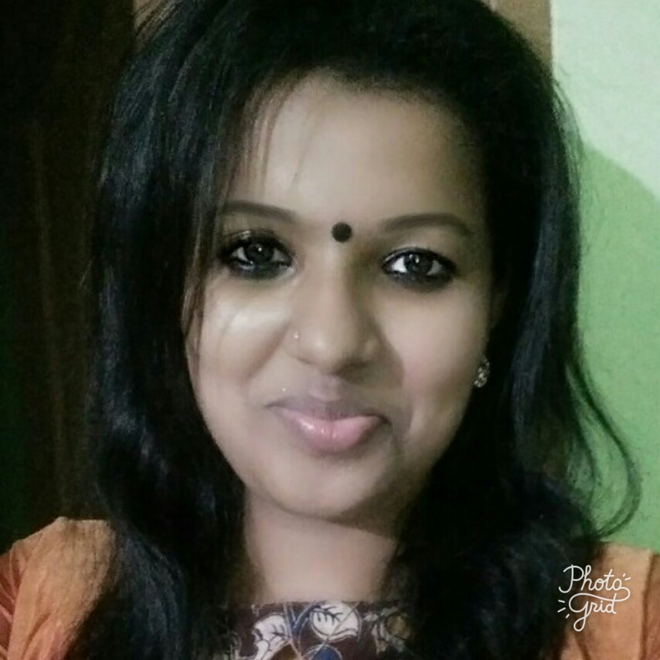

Place: Vytilla
Date:

