CURRICULUM VITAE
PERSONNEL DETAILS |  | 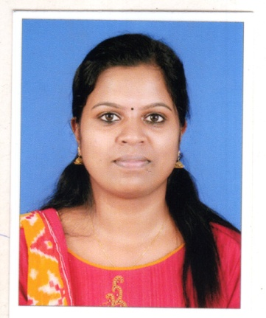
NAME | REEJA JANARDHANAN

FATHER NAME | JANARDHANAN TK
SPECIALITY | STAFF NURSE
DATE OF BIRTH | 27 JAN 1994
GENDER | FEMALE
MARITAL STATUAS | SINGLE
RELIGION | HINDU
NATIONALITY | INDIAN
CORRESPONDANCE ADDRESS | DEVATHUNKAL –HOUSE  RANIMUDI  LAKSHMIKOVIL PO,PEERUMADE  IDUKKI  KERALA-685531
PERMANENT ADDRESS | SAME AS ABOVE
CONTACT NUMBER | 8157848502
EMAIL | Reejajoseph123@gmail.com
PASSPORT DETAILS | PASSPORT NUMBER :PG811888  PLACE OF ISSUE :KOCHIN  04/5/2016 TO 03/05/2026
ACADEMIC QUALIFICATION

NAME OF INSTITUTIN | PANCHAYATH HSS VANDIPERIYAR
YEAR OF PASSING | 2009
MARK OBTAINED | 84%
QUALIFICATION OBTAINED | SSLC
NAME OF INSTITUTION | THSS PEERUMADE
YEAR OF PASSING | 2011
MARK OBTAINED FOR PLUS TWO | 70%
PROFESSIONAL QUALIFICATION
NAME OF INSTITUTION | INE SME PALA
YEAR OF PASSING | 2016
MARK OBTAINED | 63%
QUALIFICATION OBTAINED | BSC NURSING
MEBERSHIP/REGISTRATION
REGISTRATION WITH | REGISTRATION NO | PERIOD
KERALA NURSES AND MIDWIVES COUNCIL | KL03201603878 | 22/3/2016 TO 21/3/2021

PROFESSIONAL EXPERIENCE
NAME OF INSTITUTION | AMRITHA INTITUTE OF MEDICAL SCIENCE,KOCHI
BED CAPACITY | 1,200
POSITION | STAFF NURSE
AREA OF EXPERIENCE | GENERAL MEDICAL WARD
PERIOD | 5/10/2016 TO 2/11/2018

HOSPITAL DETAILS

AMRITA INSTITUTE OF MEDICAL SCIENCES AND RESEARCH CENTRE,COCHIN a multi speciality hospital with 1200 patient bed ina charitable institution run by MATA AMRITHANADAMAYI MATH and has been awarded ISO 9001-2000,NABH(National Accreditation Board for Hspital & Health care system),NABL(National accreditation Board and Laboratories) certification and NACC-A Grade(National Assessment&Accreditation Council)

MAJOUR DUTIES AND RESPONSIBILITIES
ROUTIENE PROCEDURES IN THE WARD:
- Total Patient Care
- Administratin Of Medication
- Assisting doctors for rounds and procedures
- Maintaining records &reports of patients
- Act as a bridge between doctors and patients
- Providing physical & emotional support for patients and family members
- Frequent monitoring for foetal heart rate with the aid of Doppler.
- Ward management
- Care of equipment
- Addmission and discharge of patients
- Act as a role model for junior staffs
- Act as a team leader

EQUIPMENT HANDLED
- Thermometer
- Glucometer
- Sphygmomanometer
- Nebulizer
- Oxygen cylinder
- Suction apparatus
- Doppler
- Pulse oxymeter
- Syringe pumb
- Infusomate

PERSONAL SKILLS
- Hard working with positive attitudes
- Can work well with team members
- Able to perform responsibilities in time
- Communication skill
- Leadership skill
- Cooperative

REFERENCE
- Dr Arun Vivek
Pain and palliative department
Amrita institute of medical science and Research Centre
Elamakara,kochin-682041
Kerala,india
Phone -0484-2801234

- Dr Asmitha Mehtha
HoD –Pulmonary medicine
Amrita institute of medical science and Research centre
Elamakara,Kochin-682041
Kerala ,India
Phone 0484-2801234
- Sr Shyni
Nursing –in –Charge
Amrita institute of medical science and Research centre
Elamakara,kochin-682041
Kerala,India
Phone ;+919846767620

I hereby declare that all the particulars given in my curriculum vitae are true to the best of my
knowledge and belief.

Place kottayam
Date; (Reeja Janardhanan)

DECLARATION

