**Divya.V.Tajan**

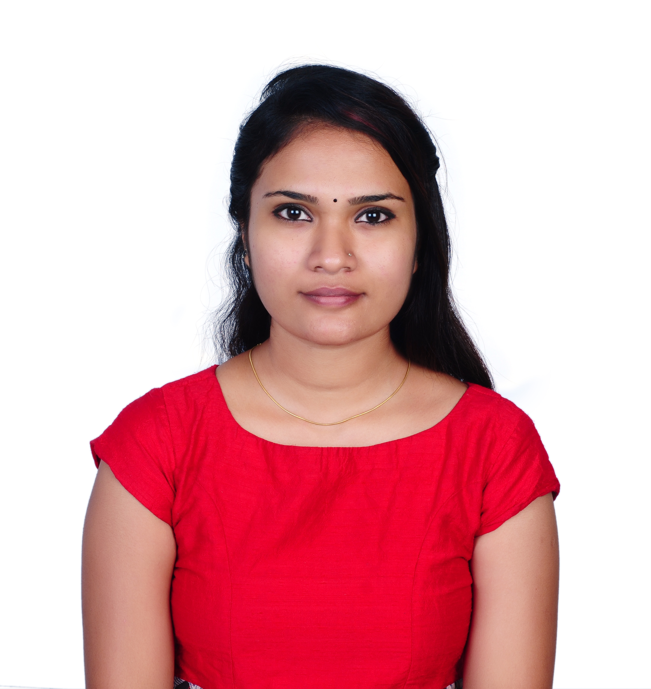

DivyaDeepthy, Kurisumuttom

Perukavu P.O,Trivandrum,

Kerala -695573

Mob: 8547414497

divyatajan@gmail.com

# EDUCATIONAL QUALIFICATIONS

|  |  |  |  |
| --- | --- | --- | --- |
| **Course** | **Institute** | **Year of Passing** | **CGPA/Percentage** |
| MSW (Medical & Psychiatry) | Madras Christian College, Chennai | 2018 | A++ ( 71.62) |
| BSW | Rajagiri College of Social Sciences, Kerala | 2016 | 7.64 |
| 12th | Carmel Girls HSS, Trivandrum, Kerala | 2013 | 78.1 |
| 10th | Holy Angels Convent HSS, Trivandrum, Kerala | 2011 | 2A+ ,2A, 2B+, 4B |

# SKILLS

* Interpersonal skills
* Managerial skill
* Coordinating skill
* Reporting and documentation
* Computer skills on MS Office, PowerPoint, SPSS.

**JOB EXPERIENCE (1 Year)**

Worked as Project coordinator for Oasis India from 2018-2019 for their pilot project.

# ACADEMIC PROJECTS

* **A study on relevance of life skill education among adolescent girls (Duration: 1 year)**

To study the importance of life skills in adolescent girls and also to study the awareness the adolescents have about life skills and using it in daily life.

* **A study on attitude of male social work students on increasing violence against women (Duration: 1 year)**

This study was conducted to know the attitude of the social work students on the Violence's that happen against women.

# ACADEMIC ACHIEVEMENTS

* **Overall excellence prize** for Masters in Social work from Madras Christian college 2016-2018
* **Special Prize** in academics from Madras Christian College for the academic year 2015-16.
* Secured A+ grade in “Accounting on Computers” using Tally.ERP from Manvish academic council.
* Served as a Voluntary Executive for District Kudumbasree Mission, Ernakulam
* Certificate Course in “Participatory Rural Appraisal training”

# EXTRA-CURRICULAR ACHIEVEMENTS

* First prize in face painting on Mind meet 2017 from The Banyan Academy of Leadership in Mental health
* Participated in **“Folk and Human Media Workshop”** conducted by Alternative Media Centre 2016.
* Organized and was the Master of Ceremony for the International social work conference, **“DYUTI”** consecutively for 2 years.

# PERSONAL PROFILE

* Date of Birth : 20/10/1995
* Marital Status : Single
* Nationality : Indian
* Languages known : English, Malayalam, Hindi, Tamil
* Hobbies : Reading books, Listening music, Drawing, Crafts making