- PERSONAL INFORMATION
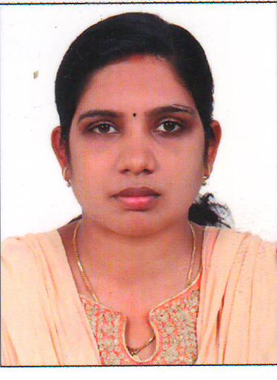
Name : SARITHA BHASKARAN
Date of birth : 04.12.1989
Gender : FEMALE
Passport no : TO404953
Date of expiry : 06.12.2028
Father’s Name : P.A. BHASKARAN
Nationality : INDIAN
Religion : HINDU
Address : MAMPURATHU (H)
MULAKULAM (N)P.O.
PIRAVOM
EERNAKULAM DIST
KERALA, INDIA –686664.

Contact No : +91 628243395S , +91 9496700740
Email ID : sarithabhaskaran1989@gmail.com
Marital status : Married
Spouse’s Name : NISHAD M.M
Hobbies : Listening music, Reading books
Languages known : English, Malayalam & Hindi

- CAREER OBJECTIVE

Continue to develop the potentials in the professional career and thereby make a significant contribution towards mankind.

- STRENGTH

Ability to communicate with patient and their relatives effectively about the treatment. I am enthusiastic and have willingness to learn and a self motivated person.

- EDUCATIONAL QUALIFICATION

EXAMINATION | NAME OF BOARD/UNIVERSITY | YEAR OF PASSING | % OF MARKS
Secondary School(SSLC) | Board of Public Examinations, Kerala | 2006 | 70%
Higher Secondary School(plus two) | Kerala Board of Higher Secondary Examinations | 2008 | 70%

- PROFFESSIONAL QUALIFICATION & REGISTRATION

EXAMINATION | NAME OF INSTITUTE | YEAR OF PASSING | % OF MARKS
Diploma in General Nursing and Midwifery | KLEU Institute of Medical Sciences, Belgaum, Karnataka | 2011 | SECOND CLASS
Professional Registration | Kerala Nursing Council | 2013 | Registration No. 92372

- CLINICAL EXPERIENCE

Name of Hospital | Designation | Department | Duration
K.L.E.S Dr. Prabhakar Kore Hospital, belgaum, karnataka | STAFF NURSE | C.C.U | 21/07/2014  to  28/06/2013  (1 year)
SREEVALSAM INSTITUTE OF MEDICAL SCIENCE HOSPITAL, NADUVATTOM, EDAPPAL | STAFF NURSE | General Ward | 21/07/2014  To  17/06/2016  (2 year)
LISIE HOSPITAL, KOCHI | STAFF NURSE | Cardiology Unit | 26/05/2016  To  22/01/2019  (2 years)

- MACHINE FAMILIARITIES
- Cardiac Monitor
- Mechanical Ventilator
- Syringe Pump
- CPAP Machine
- BIPAP Machine
- ECG Machine
- IABP Machine
- TPI Machine
- Defibrillator Machine
- CO2 Monitor
- Suction Machine
- CVP Monitoring Machine
- Arterial Blood Monitoring Machine
- WELL KNOWN PROCEDURES

- Venus Line Cannulation
- Catheterization
- CPR
- Intra Venous, Intra Muscular, Subcutaneous, Intra dermal Administration of Medicines
- Cardio version
- ECG Monitoring
- ET and Oral Suction
- RT Feeding
- Wound Dressing
- And all other basic procedures

- COMPUTER SKILLS

- Basic Computer Knowledge

- REFERENCE

- Mrs. NIRMALA
NURSING SSUPERINTENDENT
SREEVALSAM INSTITUTE OF MEDICAL SCIENCES
EDAPAL.

- DECLARATION

I, hereby declare that all the above information are correct and true to the best of my knowledge and belief.

Place: PIRAVOM SARITHA BHASKARAN
Date:

