CURRICULUM VITAE

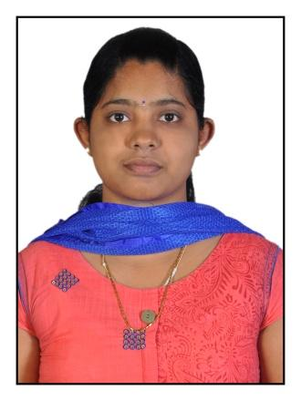

AMALA JOSEPH
PUTHUPARAMBIL HOUSE
KAKKUDUMON (po)
PATHANAMTHITTA DIST.
KERALA, INDIA
Pin: 689711
PH: 9446477898
Email:amalajoseph222@gmail.com

CARRIER OBJECTIVE

To obtain a better carrier prospects in the field of nursing, by getting an opportunity to prove myself as an exemplary nurse.

PERSONAL DETAILS

Name :AMALA JOSEPH
Father’s Name :JOSEPH PC
Date of Birth :10-12-1994
Sex :Female
Religion :Christian
Marital Status :Single
Nationality :Indian
Designation :Registered Nurse & Registered Midwife (RNRM)

Permanent Address :puthuparambil house
kakkudumon (po)
pathanamthitta dist.
kerala, india
pincode: 689711

Contact No. :Mob: 9446477898

E-mail ID :amalajoseph222@gmail.com
Languages Known :English, Malayalam, Telugu

PASSPORT DETAILS:

Passport number : R6001305
Date of issue : 26-12-2017
Place of issue : TRIVANDRUM
Date of expiry : 25-12-2027

ACADEMIC QUALIFICATION

Examination Passed | Institution | Board/University | Subjects | Year of Passing | Division & % of Marks
S.S.L.C. | SCHSS RANNI | Kerala State Board of Public Examination | All subject | 2010 | First Class  72%
Plus Two | SCHSS RANNI | Kerala Board of Higher Secondary Board | Science Group | 2012 | First Class  65.5%

PROFESSIONAL QUALIFICATION

Examination Passed | Institution | Board /University | Year of Passing | Division & % of Marks
B.Sc. Nursing | Narayana College of Nursing , Nellore, Andhra pradesh | Dr. NTR University of Heath Sciences , Andhrapradesh | 2016 | 67.4%

PROFESSIONAL REGISTRATION

Organization | Membership Status | Membership No. | Date of Enrollment
Andhra pradesh State Nursing Council | Staff Nurse | Nurse: 179097  Midwife: 178650 | 06-04-2017

EXPERIENCE DETAILS

- Working as a Staff Nurse in Narayana Medical College Hospital, Nellor, Andhrapradesh from 12th January 2017to still continuing in Dialysis Dept.

- This Hospital is an ISO-2001 certified hospital with 1250 bedded

- In our hospital, we have been caring patients with high standard procedures and equipments
- The dialysis unit has been well facilitated with 22 dialysis machine and 1 CRRT machine, emergency intubation equipments and other critical area equipment
PROCESURES ASSISTED
AVF cannulization, jugular, femoral and subclavin catherization, kidney biopsy and intubation
EQIPMENTS HANDLED
Dialysis machine, RO plant,cardiac moniter, pulse oxymeter, nebulizer, oxygen cylinder, laryngoscope, BP apparatus, infusion pump, centralized oxygen supply, centralized suction apparatus
DIALYSIS MACHINE EXPERIENCE
- Fresenius 4008S
- B-Braun dialog plus

SKILLS ABLE TO PERFORM
- Able to handle CKD patients with suitable care required

- Able to handle comfortably with dialysis machine mainly Fresenius, B-Braun
- Can handle cases of CRRT, plasmapheresis, heamoprfusion

- Able to handle AVF cannulization HD sheaths[jugular and femoral]

- IV cannulation for adult and peadiatric

- Positioning of patients

Skills:

- Good interpersonal and communication skills.
- Sincere, hardworking and commitment to excel in the given field
- Willingness to utilize abilities developed through my experience and education with intent to grow professionally
- Good analytical skills with problem sloving capabilities sense of responsibilities and creative

REFERENCE
INDIRA
Nursing Dean
Narayana Medical College
Nellore, Andhra Pradesh.

Declaration
I do hereby declare that the above furnished information is true to the best of my knowledge and belief.

Place: RANNI
Date: MISS. AMALA JOSEPH

