RESUME
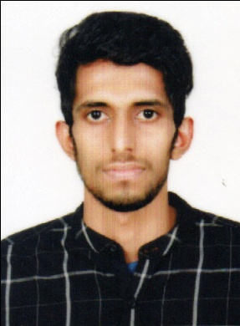
,

PERSONAL PROFILE:
Name : MUHAMMAD RAMEES P
Father’s Name : Moidu Haji
Permanent Address : Thoduvakkandi House
Poolakkool P O
Kozhikode
Pin 673507

Date of Birth : 24.03.1999
Contact No : 9995365274
E mail : muhammadrameestk@gmail.com
Marital Status : Single
Nationality : Indian
Sex : Male
Languages Known : English, Malayalam and Hindi

EDUCATIONAL QUALIFICATION:
- SSLC
- Plus Two
- Diploma in CSSD Technician

EXPERIENCE:
- 18 months at Lourdes Hospital during the Course period

SUMMARY:
Aim to be associated with the organization that provides me an opportunity to show my skills and improve my Knowledge with latest trends and to be part of the team that works dynamically towards the growth of the Organization.

STRENGTH:
I believe in smart and hard working my locality and sincerity will be the key for my success.

DECLARATION:
I hereby declare that the information provided above is accurate and recent to the best of my knowledge and belief.

Place:
Date: MUHAMMAD RAMEES P

