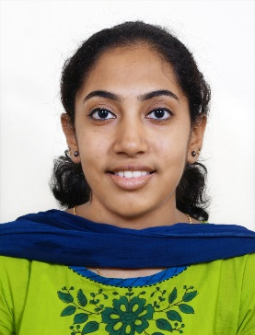
Dr Riya Mary Jacob
8606429479
riyaeln@gmail.com
TCMC Reg No: 70913

CAREER OBJECTIVE
To be part of a work culture that provides me the opportunity to put my skills to its best use and in turn assist my personal development.

EDUCATIONAL DETAILS
- Bachelor of Medicine and Bachelor of Surgery (MBBS) from DM WIMS Medical College, Wayanad.
- HSC from S.D.A school, ISC board.

INTERNSHIP
Undergone Compulsory Rotatory Residential Internship (CRRI) from DMWIMS Medical College, Wayanad during the period 1st April 2018 – 8th April 2019
Handled as intern:
- Assisting the senior doctor in checking patients.
- Diagnosing the disease as per the symptoms.
- Observing and performing the examination of samples for disease diagnosis.
- Learning the diagnostic methods and equipments.
- Periodically meeting the patients and observing their improvements and making reports.
- In case of emergency giving the basic treatment to the patients.
- Helping other medical staff in performing their duties.

INTERESTS
Travelling

PERSONAL DETAILS
Date of Birth: 27/04/1994
Languages known: English, Malayalam, Hindi
Address: VILLA NO: 29
DD VILLAGE, MAY FIRST ROAD
THAMANNAM PO
KOCHI – 682032

