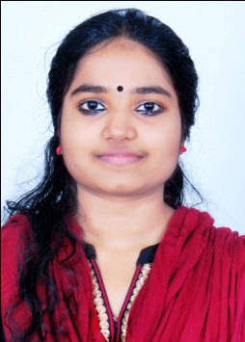

UNNIMAYA M L
Mangalath (H), Pallinada
LPS Road, Palarivattom P.O
Ernakulam, Kochi – 682 025
+91 -9745735803
unnimayaml10@gmail.com
--------------------------------------------------------------------------------------------------------------------------------------

OBJECTIVE
To be part of a reputed organization which provides a steady career growth along with job satisfaction, challenges and give value contribution in the success of the organization.

EDUCATIONAL QUALIFICATION
B. Com | N.S.S Arts & Woman’s College Tripunithura | 2015
Plus Two | N.S.S Arts & Woman’s College Tripunithura | 2012
SSLC | C.K.C.G.H.S Ponnurunni, Ernakulam | 2010

COMPUTER KNOWLEDGE
- Tally erp 9
- Soware (win Trader)
- MS Office
- Internet Browsing
- Data Entry

KEY SKILLS
- Analytical thinking, planning.
- Accuracy and Attention to details.
- Organization and prioritization skills.
- Problem analysis, use of judgment and ability to solve problems efficiently.

..2..

LANGUAGES KNOWN
- Malayalam (Reading, Writing & Speaking)
- English (Reading, Writing & Speaking)
- Hindi (Reading, Writing)

WORK EXPERIENCE
- Eight months experience as office in charge post cum accountant at Popinjay Events and Media, Palarivattom from October 2015 to June 2016
- Two years experience as Accountant at We mart Hyper mart palrivattom from 1st January 2017 to 31st December 2018

PERSONAL DETAILS
Father’s Name | Mr. Lohithakshan
Date of Birth | 22-10-1994
Gender | Female
Religion | Hindu
Nationality | Indian
Marital Status | Single
Interests & Hobbies | Travelling and Reading books

DECLARATION
I hereby declare that the above furnished statements are true to the best of my knowledge and belief.

Place: Palarivattom
Date:

UNNIMAYA M L

