PERSONNEL DETAILS
Date of Birth: 27 Feb, 1993
Gender: Female
Nationality: Indian
Marital Status: Married
Spouse Name: Joseph Judson Ponsek
Father’s Name: P. M. Joseph

COMPUTER LITERACY
- MS OFFICE
- Basic Internet

LANGUAGES KNOWN
- English
- Malayalam
- Hindi
- Tamil

INTERESTS
- Drawing
- Making tricky lecture notes for study purposes.

FINCY JOSEPH. p
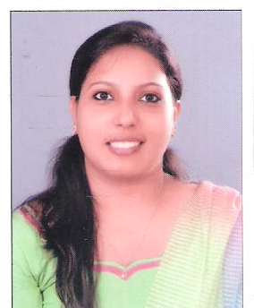

Puthenpurackal(H), Konthuruthy,
Thevara-682 013
Email: fincytanzen93@gmail.com
Ph: +91 8078466900, 8592977440

CAREER OBJECTIVE
To build a career in finance field, to work in a challenging environment, to be a good team member, to grow with the organization so as to improve the career prospectus.

EDUCATION
- Master of Commerce:2013-2015--75%
Sacred Heart College Thevara, Kochi.

- Bachelor of Commerce:2010-2013--83%
Sacred Heart College Thevara, Kochi.

- Plus Two:2010--80%
Sacred Heart Higher secondary, Thevara, Kochi.

- S.S.L.C:2008--84%
C.C.P.L.M Anglo Indian High School, Thevara.

EXPERIENCE
- Accountant at Denwud Exim India LLP (Since 2015) - Still working

ADDITIONAL QUALIFICATION
- Tax practitioner course May 2013
- Tally 7.2

PROJECTS DONE
- A study on Financial and Non-Financial schemes provided by the FISHERIES DEPARTMENT to fishermen(2015).
- Brand preference for mobile phones in Ernakulam city (2013).

WORKSHOPS ATTENDED
- Lead world 2013 (Leadership for Change)

ACHIEVEMENTS
- Consistency in academics.
- Secured 1st prize in CARTOONING in the interdepartmental literacy-cultural competition “HRDYASARGASANGAMAM 2012-13”
- Secured various prizes for PRABHASHANAM (Sanskrit) competition under Ernakulam Educational Sub-District Sahithyolsavam.
2006-07 B grade
2005-06 3rd B grade
2004-05 2nd A grade
- Secured 1st prize in News Paper Making competition 2006
- Secured 2nd A grade in THIRUVATHIRAKALI in Ernakulam Educational Sub-District Yuvajanolsavam.

REFERENCE 1 REFERENCE 2
Prof. Sajoy P B Sinoj Tharian
Faculty of Commerce Dept Director : Denwud Exim India LLP
S.H College Thevara Perumbavoor
Kochi-682013, Ph 98951 64350 Ph: 9645534320

DECLARATION

I hereby acknowledge and declare that all information above provided by me is true.

Fincy Joseph. P Place: Cochin
Date: 28/05/2019

