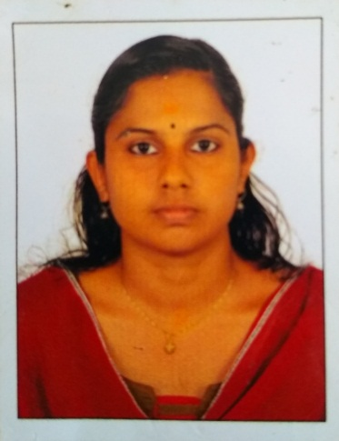 Email : priyanka7972@gmail.com
Contact No: 09645697972

objective

To strongly contribute the best of my skills and abilities to the success of the organization as well as my career, through a concept of learning from experiences and adding value to the organization.to excel in the work assigned to me, with most perfection and precision.

Academic details

- Bachelor of Science with specialization in zoology (2012-2015) from Marthoma college, Tiruvalla with 75% marks (M.G University).

- Higher Secondary( 2010-2012) St’ Theresas BCHSS Chengaroor with 84% marks(board of higher secondary examination kerala

- Secondary school leaving certificates certificates(SSLC)2010 with state board kerala.

Computer awareness

- Diploma in foreign accountancy(DIFA)

- M.S office(Typing speed 50 WPM)

Language Known

- Malayalam ,English ,Hindi.
Core Competencies

- Positive Attitude

- Communication Skills

- Dedication to Work.

- Confident & Adaptable

Personal details

Father name : Ponnappan

Mother name : Sindhu ponnappan

Husband name : Arunraj

Date of Birth : 01-03-1993

Sex : Female

Nationality : Indian

Religion & Caste : Hindu , Ezhava

Address : Arunnivas,kozhimala po

Vallamkulam,Tiruvalla.

Pathanamthitta.

Working experience

Medical records department staff at belivers church mission-
hospital tiruvalla.(2016-)

References

- Prof.Dr.Reema Achiyamma Mathew
Head of the department, Marthoma collage,Thiruvalla.
Contact No: 09447586340

- Jiji George , (supervisor ,belivers hospiatal Medical Records Dipartment)
Contact No:09495606355.

