CURRICULUM VITAE

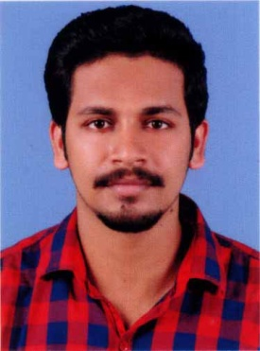

JEWEL ANTONY
VITHAYATHIL (H)
NARIVELI, ANAKKAL P.O.
KANJIRAPPALLY
KOTTAYAM
KERALA - 686508
MOB: 8086812009, 9446828853
Email: jewelantony3@gmail.com

OBJECTIVES

To obtain a challenging position with an establishment, where my work experience will be fully utilized with opportunity for upward mobility based on my performance and achievements.
PERSONAL DETAILS
Father’s Name : V.O. Antony
Sex : Male
Nationality : Indian
Age & Date of Birth : 23, 25-05-1995
Marital status : Single
Email ID : jewelantony3@gmail.com
Languages known : English & Malayalam
Hobbies : Travelling, Driving.

EXPERIENCE

- Working as an Assistant Accountant at Saji Philip Associates, Kanjirappally from June 2016. (2years and 6months of experience)

EDUCATIONAL QUALIFICATION

Course | Institution | Board / University | Year of Completion | Marks
M.Com Finance | Distant Education | Bharathiar University | 2019 | 60%
B.Com Finance and Taxation | ST. Dominic’s College, Kanjirapally | Mahatma Gandhi University | 2016 | 7.07  (SCPA)
Class XII | St. Dominic’s HSS, Kanjirapally | Kerala | 2013 | 81.09 %
Class X | St. Dominic’s HSS, Kanjirapally | Kerala | 2011 | 72.2 %

TECHNICAL KNOWLEDGE

- MS Office
- Tally. ERP 9

EXTRA CURRICULAR ACTIVITES
- Participated in Inter-University table tennis championship
Conducted at Govt. College, Painavu, Idukki.
- Active volunteer of NSS at St. Dominic’s College, Kanjirapally.
- Coordinator of college jubilee and career and placement cell.
- Participated in Inter-Collegiate quiz competition at Marian College, Kuttikanam.
- Participated in Inter-Collegiate product launch competition at Marian College, Kuttikanam.
- Active participant of various cultural programmes in College and School

R REFERENCE

- Prof. Anoop Tom Thomas
Dept. of B.Com (Finance and Taxation)
St. Dominic’s college, Kanjirapally.
Mob: 9961406491
- Saji Philip
Chief Accountant, Saji Philip Associates
Kanjirappally
Mob: 9447151195

DECLARATION

I do hereby declare that the above details furnished are true and correct to the best of my knowledge and belief.

Place: Kanjirappally
Date: 16-03-2019 JEWEL ANTONY

