RESUME
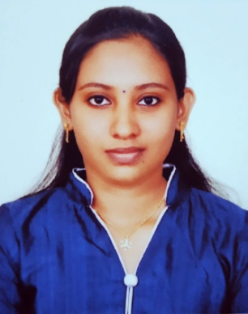
ARYA T G
THEVALIL (H),
KOTTAPURAM (P.O)
THRISSUR (dt), KERALA- 680673
INDIA
Mobile No: +919526023628
E-mail: aryagopaltg@gmail.com

CAREER OBJECTIVE
To seek a position in an organization in Medical field to utilize my skills and capabilities, to perform exceptionally and preferably in progressive and competitive work environment, where I may build upon my knowledge of patient care and medicine.

EDUCATIONAL PROFILE
Course | Institution | Board/University | Year of completion | Marks%
BSC. MEDICAL LABORATORY TECHNOLOGIST (BSC. MLT) | PRESENTATION CENTRE OF ALLIED SCIENCE | KERALA UNIVERSITY OF HEALTH SCIENCES (KUHS) | 2014- 2018 | GRADUATED
PLUSE TWO | G.V.H.D.S NADAVARAMBA | STATE BOARD | 2013-2014 | 82%
X Std  (S.S.L.C) | ST. ANNIE’S HIGHER SECONDARY SCHOOOL | STATE BOARD | 2011-2012 | 85%

ACADEMIC EXPERIENCE
Relevant Coursework
- Anatomy, Physiology, Biochemistry, Clinical Microbiology, Immunology, Serology, Haematology and Clinical Pathology, Parasitology, Mycology, Virology, Blood Bank, Cytology, Histopathology – Covered topics.
Project Work
- ROLE OF FINE NEEDLE ASPIRATION CYTOLOGY IN DIAGNOSIS AND MANAGEMENT OF THYROID DISEASES IN DIFFERENT SEX AND AGE GROUPS – Done in Lourde’s Hospital , Ernakulum , Kochi

TRAINING EXPERIENCE CERTIFICATES
Institution | Duration
LOURDE’S HOSPITAL, ERNAKULUM, KOCHI | 3 MONTHS
RENAI MEDICITY HOSPITAL, ERNAKULUM | 2 MONTHS
MALABAR CANCER RESEARCH CENTRE, THALASSERY, KANNUR | 1 MONTH

EXPERIENCE
Institution | Duration
SAKTHI DIAGNOSTIC CENTRE, KODUNGALLUR | 3 MONTHS

CORE COMPENTENCIES
- Flexible and quickly adaptable
- Leadership of peers and colleagues
- Compassionate patient care
- Efficient patient assessment/ care evaluation
- Decision-making in high pressure situations
- Effective interpersonal communication
- Organization of contributing ideas into action
- Blood Collection Using Vaccutainer system and Syringe
- Microsoft Word, Excel, Power Point

PERSONAL PROFILE
Name of Father : Gopalakrishnan.T.S
Date of Birth : 14-7-1996
Religion & Cast : Hindu, Ezhava
Marital Status : Single
Gender : Female
Nationality : Indian
Languages Known : Malayalam, English, Hindi

REFERENCE
Name : Praveena T B
Designation : Principal- in- Charge
Presentation Centre of Allied Sciences, Puthenvelikara
Phone Number : 0484-2485750

DECLARATION
I hereby declare that the information furnished above is true to the best of my knowledge and belief.

Place : KOTTAPURAM ARYA T G
Date :

