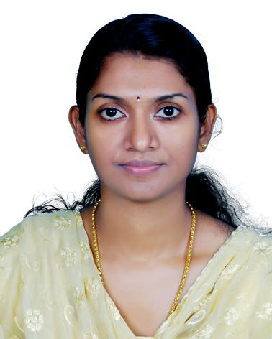
Ms. PRAVEENA ANOOP
Kayamkulam

Mobile (India): +91 9447993172
Mobile (India): +9197467417 42
: 0479 2331255
E-mail: praveenaanoop@gmail.com

A MBA Grad with 5 years hands on experience in Marketing , Accounts and Administration

Vision & Objective

In quest of career enrichment with a Leading organization of high repute and want to prove myself to be a valuable asset for the company.

Professional Experience

Organization Name | CICON REBAR SOLUTIONS (P) LTD
Work Location | Cochin, Ernakulum, Kerala
Period (Duration) | April 2015 – July 2017
position | Administrative Assistant
Responsibilities | - Provide general administration and clerical support  - Organize the scheduling of meetings  - Support budgeting and book keeping  - Create, update and maintain personnel records, financial records, and other records/data  - Manage phone calls

Organization Name | MILMA DAIRY
Work Location | Kollam, Kerala
Period (Duration) | June2011 – April 2014
Position | Marketing Organiser(Appr. Trainee)
Responsibilities | - Complaint cell duties  - Attending phone calls from customers and agents  - Place orders of milk  - Maintaining Registers  - Verifying accounts  - Complaints settlement  - Despatch duties  - Despatching milk as per order  - Maintaining stock  - Submission of reports

Organization Name | GOVT VOCATIONAL H. S. SCHOOL
Work Location | Kottankulangara, Kollam, Kerala
Period (Duration) | June2010 – March 2011
Position | VOCATIONAL INSTRUCTOR  (Marketing and salesmanship)
Responsibilities | - Lab duties  - Teaching

Skills

Well versed with Ms office
Financial Accounting(Tally)- NORKA

Academics

Education | Institute | Year of Passing | Percentage
MBA | Institute of Management in Kerala | 2009 | 66
BBA | University Institute of Technology | 2006 | 67
VHSE | Govt.VHSE, kollam  (Marketing and salesmanship) | 2003 | 73

Personal Information

- Sex: Female
- Marital status: Married
- Date of Birth: 19th Jan 1985
- Religion: Hindu
- Nationality: Indian
- Languages Known: English, , Malayalam (Mother Tongue)

PRAVEENA ANOOP
Kayamkulam,

