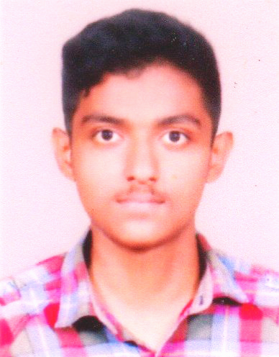  Muhammed Mubeen Kabeer  Permanent Address  Kochuparambil (H)  Civil Station Ward  Alappuzha  Bazar. P.O.,  Pin-688012, Kerala  India  Mobile:  9061967099  9567867099  E-mail :  mubeenkabeer64@gmail.com  Personal details  Father’s Name: Kabeer A M  Dob: 21 December 1997  Sex: Male  Blood group : B+^{ve}  Marital status: Single  Religion: Muslim  Nationality: Indian  Languages known:  Malayalam, English, Hindi, Tamil | Muhammed Mubeen Kabeer  OBJECTIVES  I am looking for an opportunity in the medical field where I am able to utilize my knowledge for radiographic positioning and imaging to succeed and further advance myself in the radiologic field.  ACADEMIC QUALIFICATION  - Diploma In Radiological Technology (DRT) under Directorate Of Medical Education Trivandrum, Medical Trust Hospital, Ernakulam (2018)  - Govt. Higher Secondary School, Changanacherry 2016.  - Leo XIII HSS, Alappuzha 2014  SKILLS  - Good in leading teams  - Excellent Team Worker  - Good in Communication  - Good Motivator  MALABAR CANCER CENTRE, THALASSERY 2018  - One month clinical posting in radiotherapy departments: LINAC, Cobalt 60 machines, Mould room, CT simulator, Simulator,  MEDICAL TRUST HOSPITAL  - Observation and posting in 64 slice light speed CT scanner, 1.5 T MRI scan, CR + DR radiography, Nuclear Medicine, Ultrasound. At Medical Trust Hospital, Kochi.NABH recredited multispeciality care hospital.  DECLARATION  I hereby confirm that the information given above is true to the best of my knowledge and belief.  Date :  Place : Alappuzha Muhammed Mubeen Kabeer

