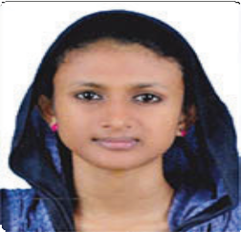
Resume for the position of HR OFFICER

Riswana 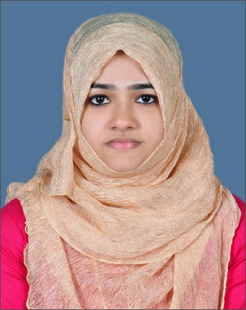
+91 9207568183

Career Objective
To face challenges, learn and delivery my best for the growth and development of HR industry.
PROFESSIONAL EXPERIENCE
- Worked as HR Consultant for H.E.C.A. HR Consultants from july 2017 to february 2018 www.higher-educations-consultants.com
Key Responsibilities –
. Approach Corporate to seek information on vacancies available for fresher’s and experienced.
. Sourcing fresher’s and experienced candidates through institutions and social media. Coordinating interview processes.
PROFESSIONAL QUALIFICATION’S
1. National Diploma in Human Resource Management from H.E.C.A. Kochi. Certifying authority, BharathSevakSamaj Vocational Education(A Central govt. Certifying agency).(From Jan 2017 to December 2017)
2. Entrepreneurship and Corporate Skills – H.E.C.A. Certificate Training in Entrepreneurship and Corporate skills (Duration 3 months), From September 2017 to November 2017.
ACADEMIC QUALIFICATIONS
• Bachelor’s Degree in Commerce
• Plus Two–From State board

Cont’d….2/-

2

Personality Traits
- Hardworking and good learner
- Optimistic
- Able to motivate & negotiate thepeople.
- Good listener

Personal Details
- DOB - 15-11-1995
- Status -Married
- Nationality - Indian
- Religion - Muslim
- Passport No -
- Languages - English &Malayalam
- Address - kadavilthazhath house Chalackal marampilly Po aluva
Declaration
Iherebydeclarethatalltheabovementionedabovearetruetothebestofmy knowledge &belief.

Date:
Place:Kochi Riswana

