  - CURRICULUM VITAE
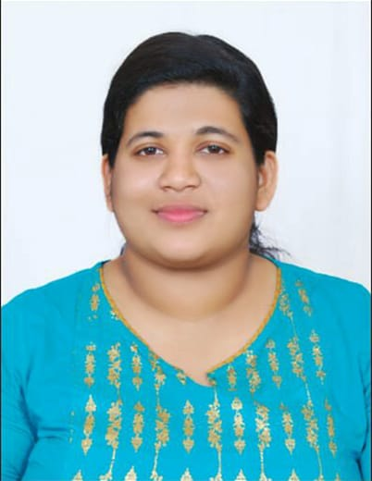
PRECIOUS ANNIE JOSEPH
Physiotherapist
Email id : preciousann913@gmail.com
Mob no: 9886537302
CAREER OBJECTIVE
Seeking the position of a Clinical Physiotherapist in a challenging and reputed organization where my knowledge and therapeutic skills will be employed in providing comprehensive care to patients and supporting the mission, vision, and values of the firm while achieving career growth and development as add on to my achievements.
ACADEMIC RECORD
COURSE |  | INSTITUTION | YEAR OF PASSING | PERCENTAGE OF MARKS
BPT | 1st Year | Nitte Institute Of Physiotherapy Mangalore | 2015 June | 60%
 | 2nd Year |  | 2016 June | 58%
 | 3rd Year |  | 2017 June | 62%
 | 4th Year |  | 2018 June | 67%
12th Board Exam |  | Mar Thoma girls higher secondary school, Thrissur | 2013March | 75%
10th Board Exam |  | Don Bosco Higher Secondary School, Thrissur | 2011March | 87%
CLINICAL TRAINING EXPERIENCE
Sl No: | DEPARTMENT | DURATION
1 | Orthopedics | 1 month
2 | Neuro/ Neurosurgery | 15 days
3 | Pediatrics | 15 days
4 | Medicine | 15 days
5 | ICU/CCU/NICU/HDU/MICU | 15 days
6 | OPD | 15 days
7 | Surgery | 15 days
8 | OBG | 15 days
9 | Community Physiotherapy  -Geriatric Rehabilitation  -Pediatric Rehabilitation | 15 days
10 | Rural Area Posting | 15 days
11 | Geriatrics | 15 days

ADDITIONAL HOSPITAL EXPERIENCE
Nitte Gajaria Hospital, Karkala, Mangalore (15 days )
Thejaswani Hospital, Mangalore (15 days)

PROJECT DETAILS
PERINATAL PHYSIOTHERAPY

WORKSHOPS AND CONFERENCES
Nitte Physio- Con 2015 National Physiotherapy Conference
Physio – Con 2017 International Physiotherapy Conference
Manipal Physio con 2017 International physiotherapy conference

PRINCIPLES OF DUTIES AND RESPONSIBILITIES
- Evaluation and education of the patient
- Assigned the tasks of planning and implementing individual intervention in collaboration with the patient by using graded exercises.
- Handled the responsibilities of monitoring and evaluating treatment to measure the progress and endure effectiveness of the intervention
- Performed various treatments for patients with diseases related to neurologic, orthopedic, cardio respiratory, oncologic, sports injuries, Pediatric etc.
- Performed the tasks of going for rounds with the concerned consultant and gaining referrals
- Handled other essential tasks as require
- Evaluation and management of ICU patients
- Assigned the tasks of preparing case notes and reports of patients
- Giving ergonomic advise for those who needed
- Handling and maintenance of electrotherapy modalities.

PERSONAL DATA
- Date of birth : 14-01-1997
- Sex :Female
- Marital Status :Single
- Languages known : Malayalam, English, Hindi , Kannada, Tamil
- Address : D/O JOSEPH SAM
Rajuvilasam House
Near to St. Thomas school
parakkode P O
Adoor
Pathanamthitta
Kerala - 691524
DECLARATION
I hereby declare that the data furnished above are true to the best of my knowledge and understanding and also willing to give my best for this institution.

DATE: 01/01/2019 Thanks and regards
PLACE: Pathanamthitta Precious Annie Joseph

