Dr. MUMTHAZ MARIYAM MOIDU

A5/93, C.H Colony, Email: marianijas5@gmail.com
Vellimadukunnu PO,
PIN: 673012 Phone: 9995359258, 9847535909
Kozhikode
CAREER OBJECTIVE
Looking for a position of Junior Resident in a reputed hospital, which can provide me constant learning, enhance my creative skills for mutual growth
EDUCATION

- Degree: Bachelor of Medicine and Bachelor of Surgery (MBBS) from Malabar Medical college Hospital & Research Centre, Kozhikode (under KUHS)
- Senior Secondary Education: Silver Hills Public School, Calicut
- Secondary Education: New Indian Model School, Sharjah

KEY SKILLS
- Good verbal and written communication skills
- Disciplined
- Punctual
- Effective decision making skills
- Hardworking and passionate

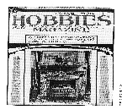
HOBBIES
- Reading
- Content writing
- travel
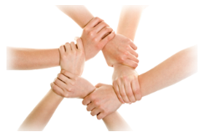
STRENGTH
- Extremely motivated towards career
- Ability to handle patients in critical conditions
- Good knowledge in clinical practices and protocols
- Flexible and adaptable
- Quick learner

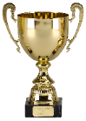
ACHIEVEMENTS

- Ranked 40th in UAE in 6th national science Olympiad
- Participant in awareness and fund raising programme under Haemophilia Federation, India
- Participant in Shastra Pratibha Contest, held in UAE under Vinjana Bharati, India
- Placed first various versification and essay writing competitions
- Individual Champion in athletics at Higher secondary School level
- Participant in INTERMEDICOZ for western vocals and Debate (English)

EXPERIENCE AS INTERN

- Worked as an intern for one year with Malabar Medical College Hospital and research centre.

Responsibilities handled:

- Observing and caring for patients admitted
- Performing basic duties like recording vitals, dressing wounds, minor suturings
- Diagnosing disease as per the symptoms
- Assisting Senior Doctors in surgery (in departments of general surgery, plastic surgery, OB/GYN, ENT and orthopaedics)
- In case of emergency giving the basic treatment to the patients
- Handling diagnostic methods and equipment.
- Checking the reports of patients
- Follow up of patients and observing their improvements and making reports
- Taking follow up from the nurses about regular treatments and dosage of patients

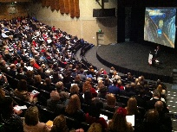

CONFERENCES ATTENDED
- Hosted RUBRO - Blood donation Registry Project at Malabar Medical College Hospital and Research Centre
- Various presentations held at MMCH and RC by different departments
- Presented symposiums on:
  - Burns and Thermal Injuries
  - Poland syndrome (case study)
  - Depression
  - Schizophrenia
  - Stroke

PERSONAL INFORMATION

DOB : 09-08-1991
AGE : 27
Marital Status : Married
Nationality : Indian
Languages known : English, Malayalam, Hindi & Arabic
Driving License : 11/12282/2013
Passport Number : J 7433149

AFFIRMATION

I Mumthaz Mariyam Moidu, hereby affirm that the information provided afore is accurate and valid to the best of my knowledge and belief and I hold myself responsible for the correctness of the content mentioned herein.

Date: 15/4/2019
Place: Kozhikode Mumthaz Mariyam Moidu

